Test Case: tc001_SPX_Dev5_Validar_Campos_Proceso_Nuevo_Articulos_Almacen
Step 1 - Enter username and password and click to button Enter : Credentials Entered
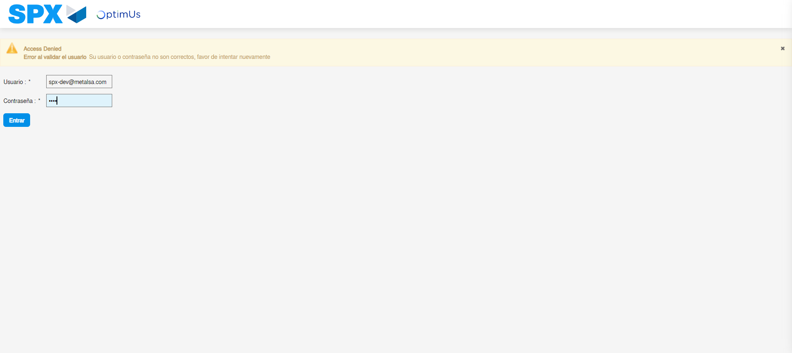Image file-name: QC_Testing-tc001_SPX_Dev5_Validar_Campos_Proceso_Nuevo_Articulos_Almacen-may. 16 2024, 04 24 02 p. m.

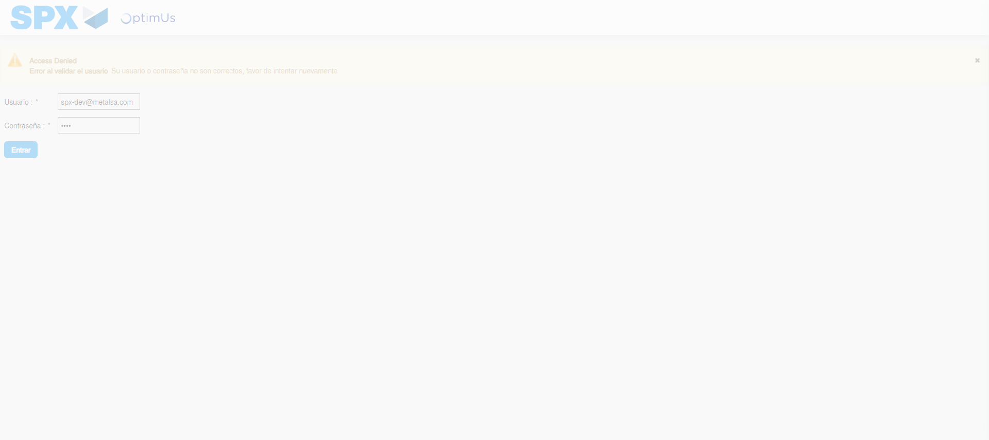Image file-name: QC_Testing-tc001_SPX_Dev5_Validar_Campos_Proceso_Nuevo_Articulos_Almacen-may. 16 2024, 04 24 03 p. m.

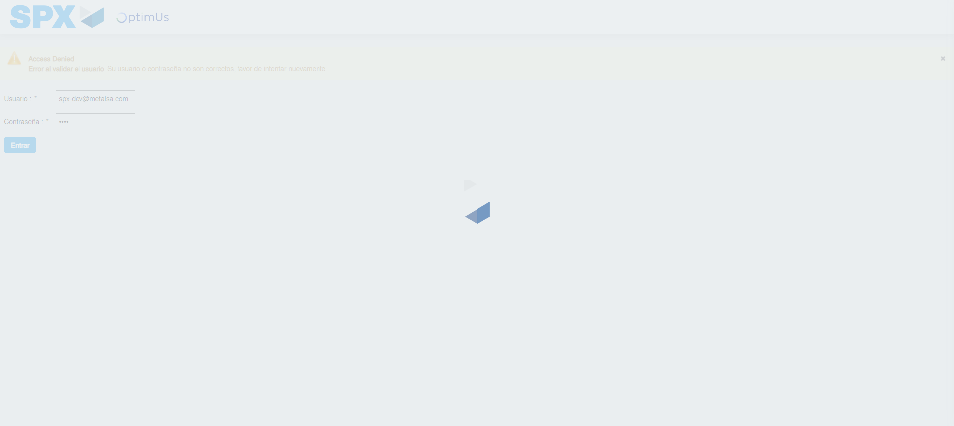Image file-name: QC_Testing-tc001_SPX_Dev5_Validar_Campos_Proceso_Nuevo_Articulos_Almacen-may. 16 2024, 04 24 04 p. m.

Step 2 - Select to UEN and Access to Articulos por Procesar: UEN Correctly selected and Correct access
Image file-name: QC_Testing-tc001_SPX_Dev5_Validar_Campos_Proceso_Nuevo_Articulos_Almacen-may. 16 2024, 04 24 08 p. m.

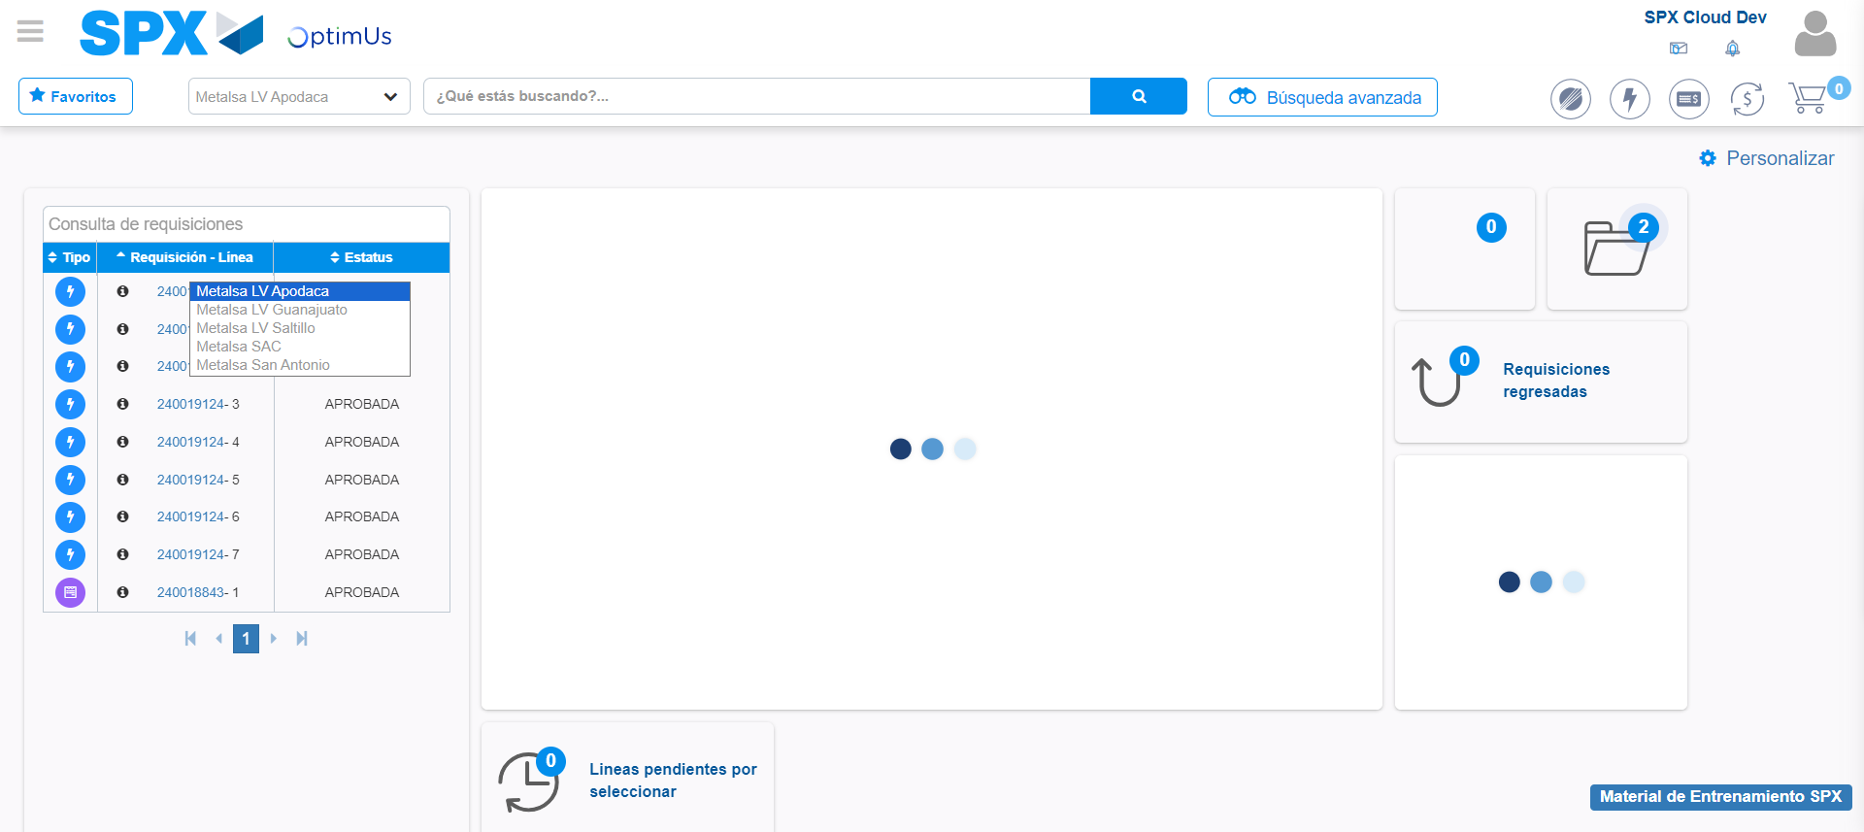Image file-name: QC_Testing-tc001_SPX_Dev5_Validar_Campos_Proceso_Nuevo_Articulos_Almacen-may. 16 2024, 04 24 09 p. m.

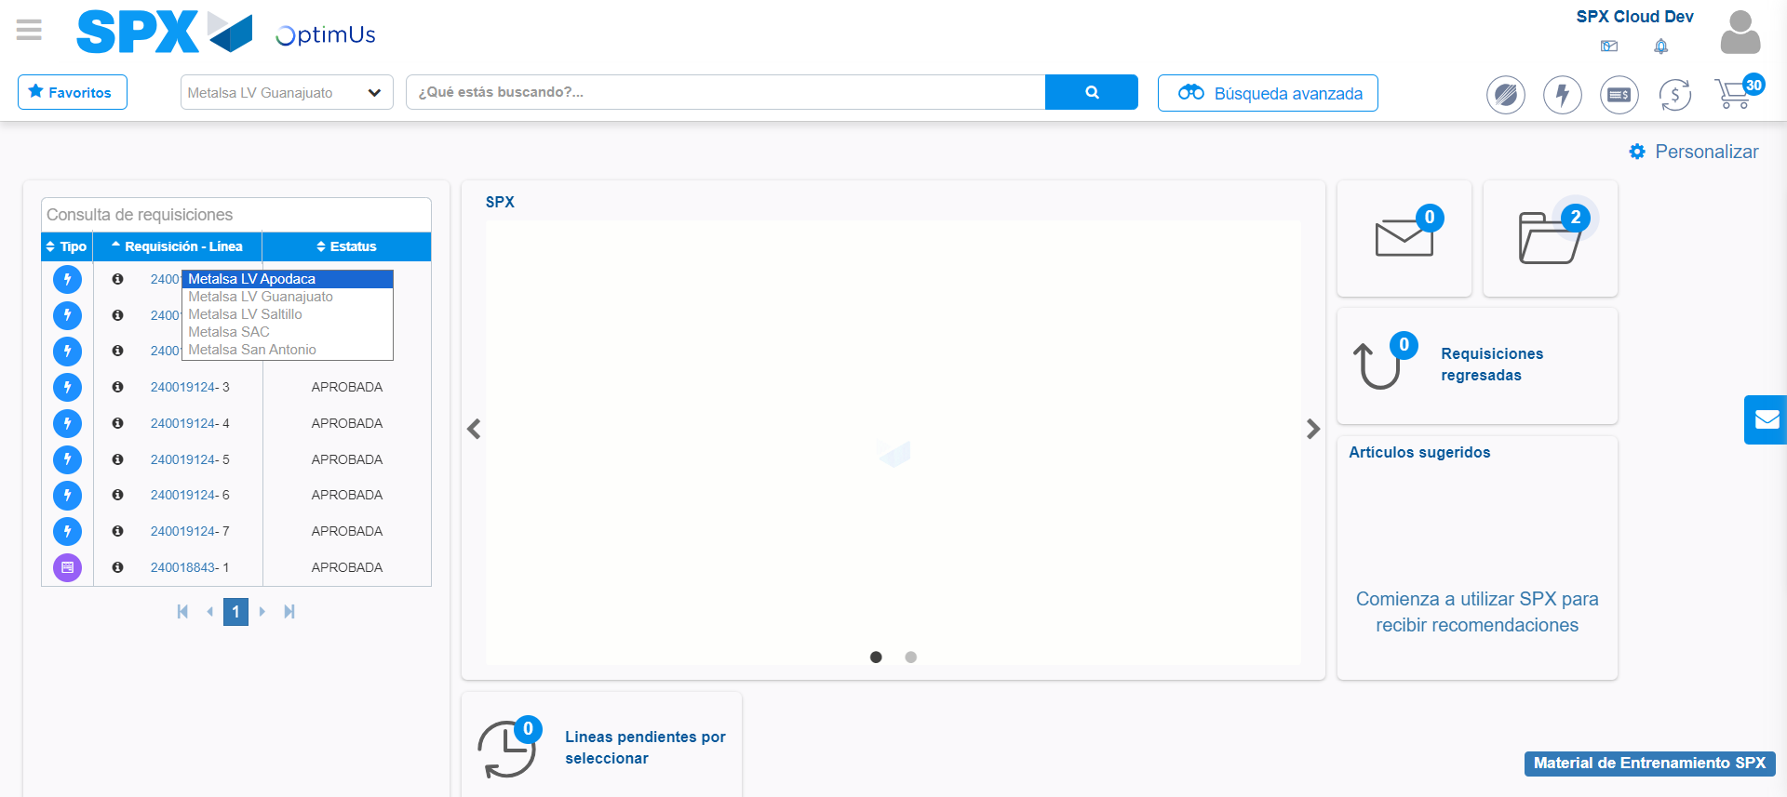Image file-name: QC_Testing-tc001_SPX_Dev5_Validar_Campos_Proceso_Nuevo_Articulos_Almacen-may. 16 2024, 04 24 10 p. m.

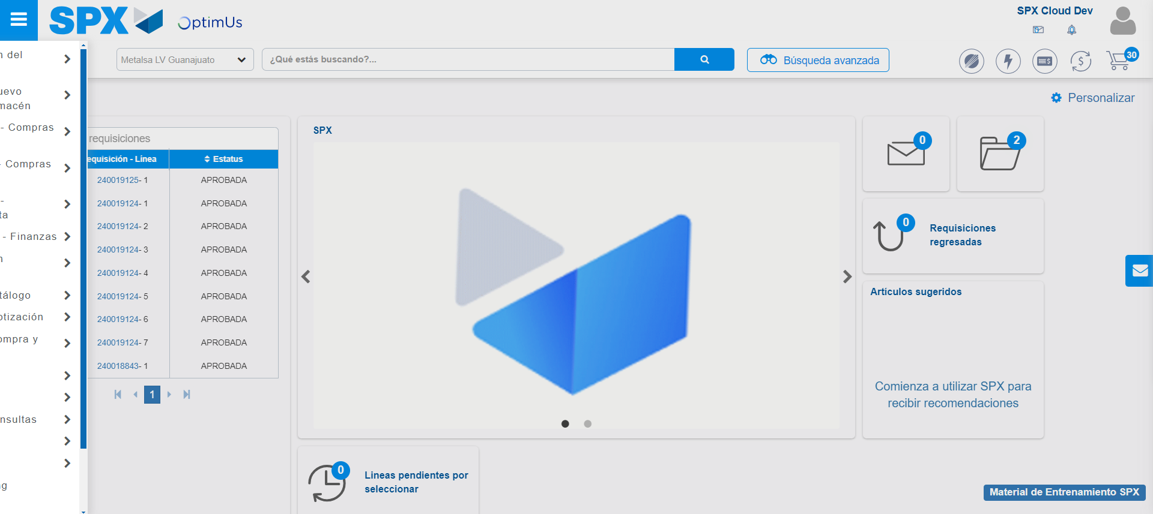Image file-name: QC_Testing-tc001_SPX_Dev5_Validar_Campos_Proceso_Nuevo_Articulos_Almacen-may. 16 2024, 04 24 11 p. m.

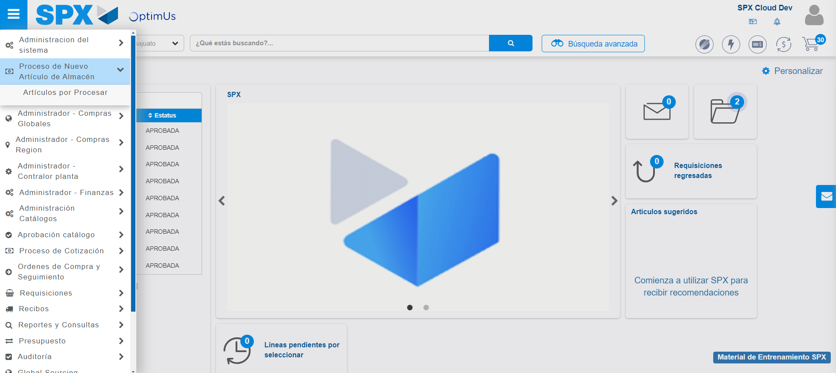Image file-name: QC_Testing-tc001_SPX_Dev5_Validar_Campos_Proceso_Nuevo_Articulos_Almacen-may. 16 2024, 04 24 12 p. m.

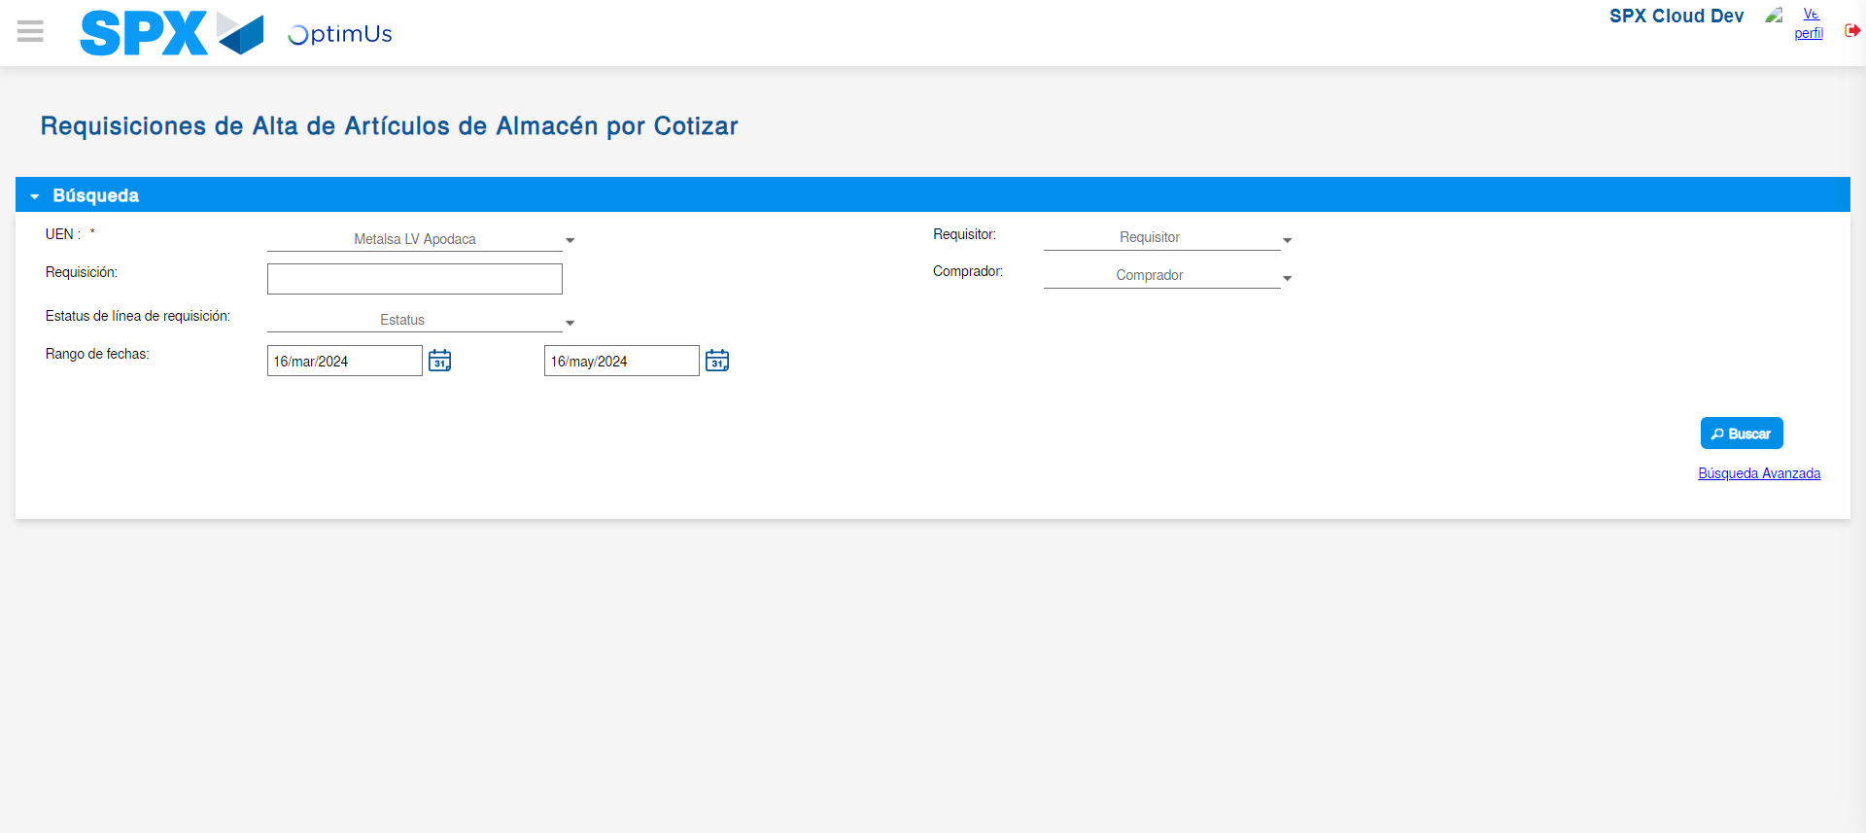Image file-name: QC_Testing-tc001_SPX_Dev5_Validar_Campos_Proceso_Nuevo_Articulos_Almacen-may. 16 2024, 04 24 14 p. m.

Step 3 - Validate search fields: Validated fields
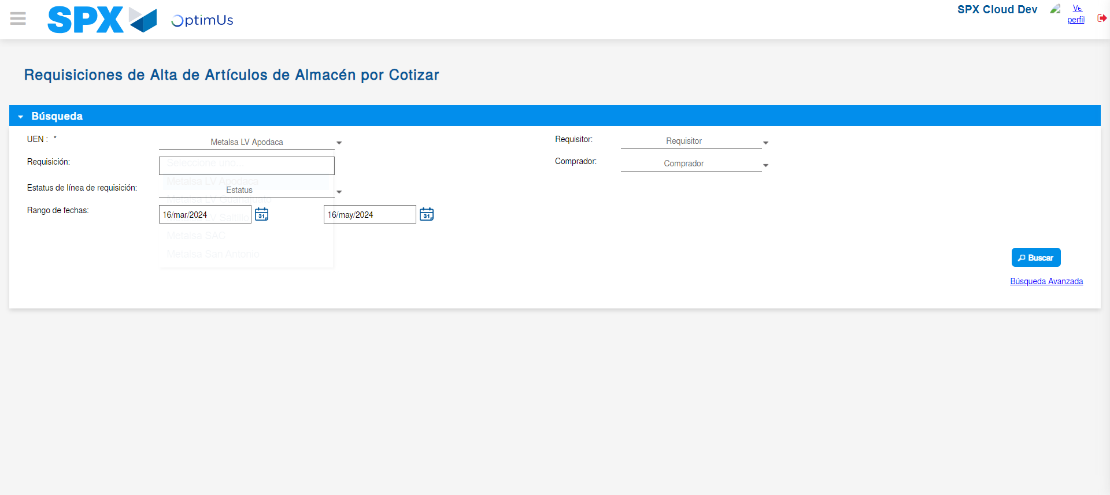Image file-name: QC_Testing-tc001_SPX_Dev5_Validar_Campos_Proceso_Nuevo_Articulos_Almacen-may. 16 2024, 04 24 15 p. m.

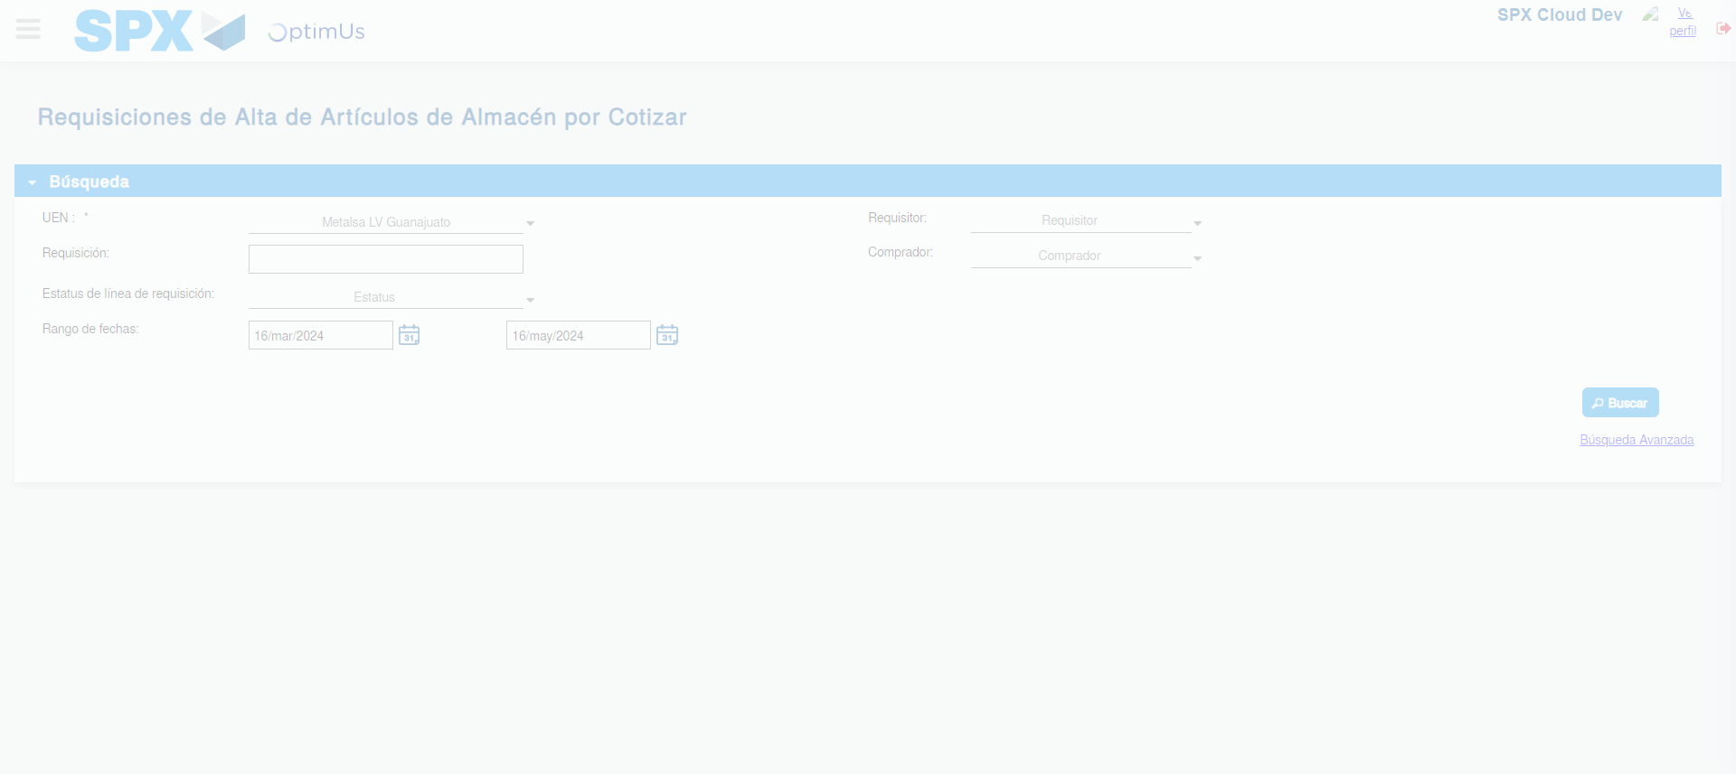Image file-name: QC_Testing-tc001_SPX_Dev5_Validar_Campos_Proceso_Nuevo_Articulos_Almacen-may. 16 2024, 04 24 16 p. m.

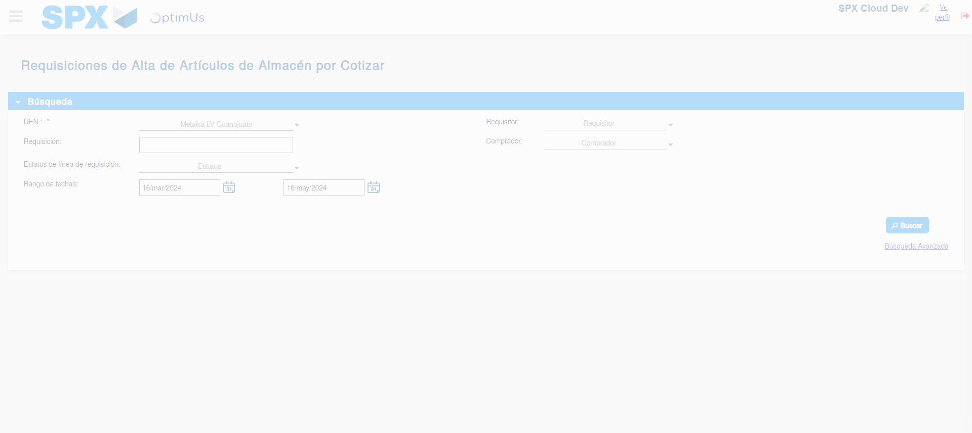Image file-name: QC_Testing-tc001_SPX_Dev5_Validar_Campos_Proceso_Nuevo_Articulos_Almacen-may. 16 2024, 04 24 19 p. m.

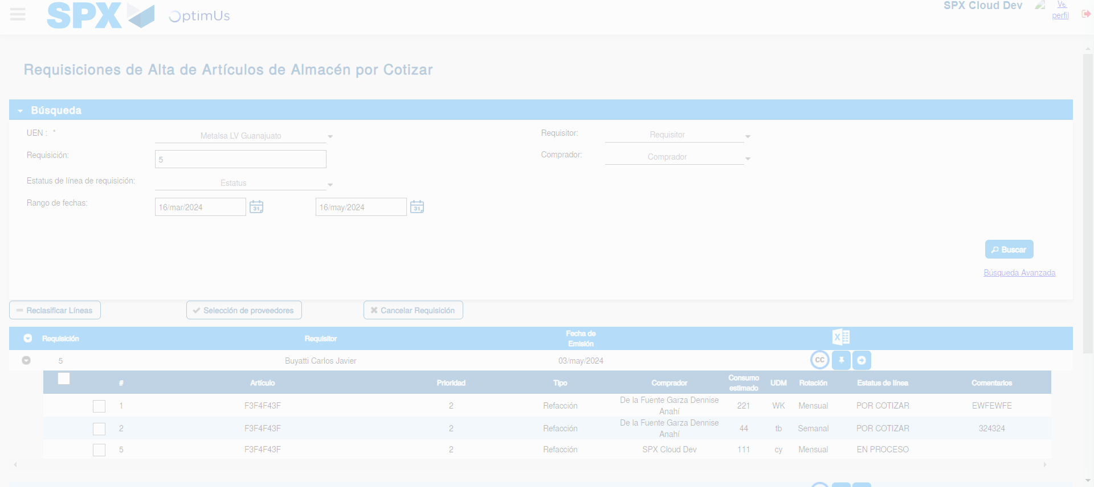Image file-name: QC_Testing-tc001_SPX_Dev5_Validar_Campos_Proceso_Nuevo_Articulos_Almacen-may. 16 2024, 04 24 23 p. m.

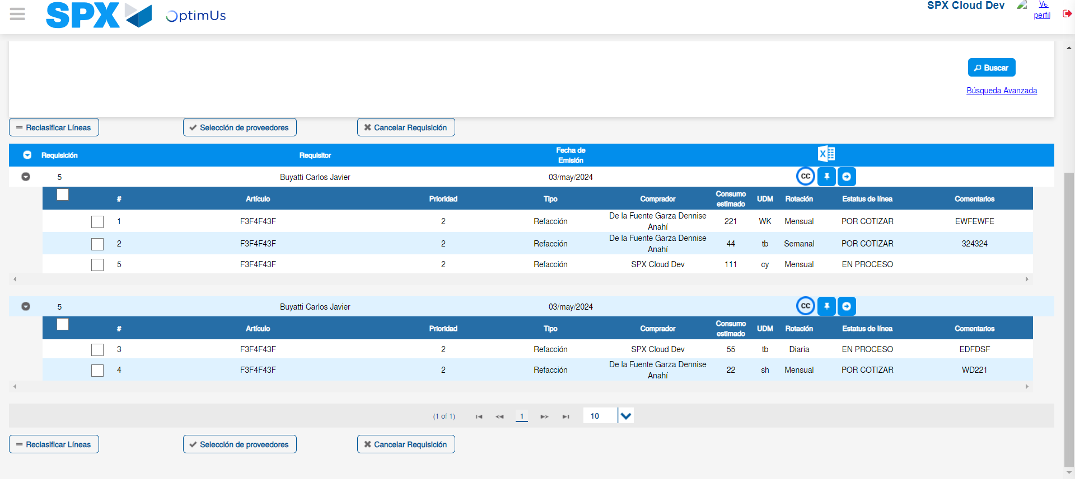Image file-name: QC_Testing-tc001_SPX_Dev5_Validar_Campos_Proceso_Nuevo_Articulos_Almacen-may. 16 2024, 04 24 27 p. m.

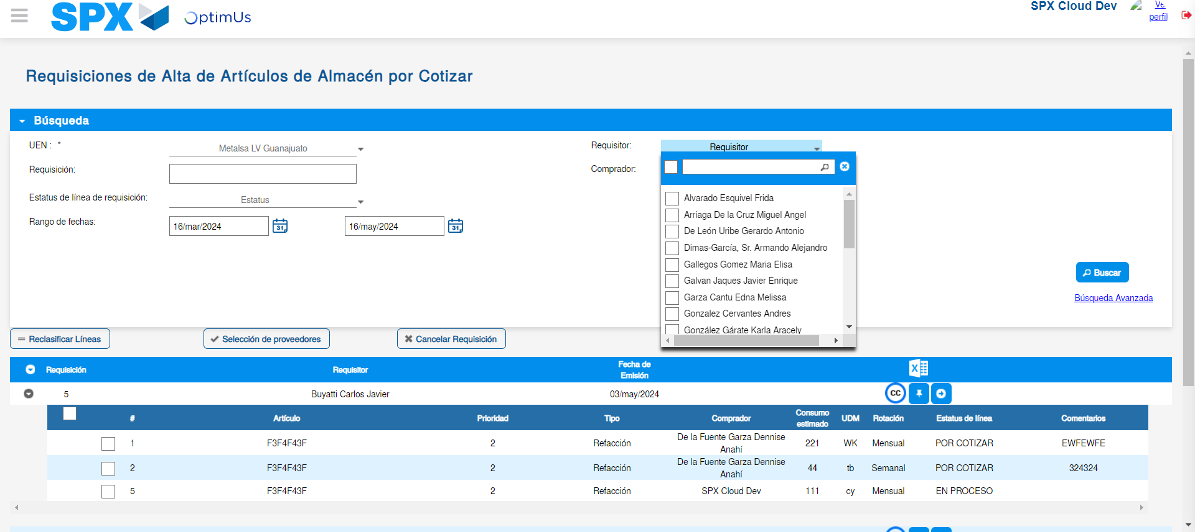Image file-name: QC_Testing-tc001_SPX_Dev5_Validar_Campos_Proceso_Nuevo_Articulos_Almacen-may. 16 2024, 04 24 28 p. m.

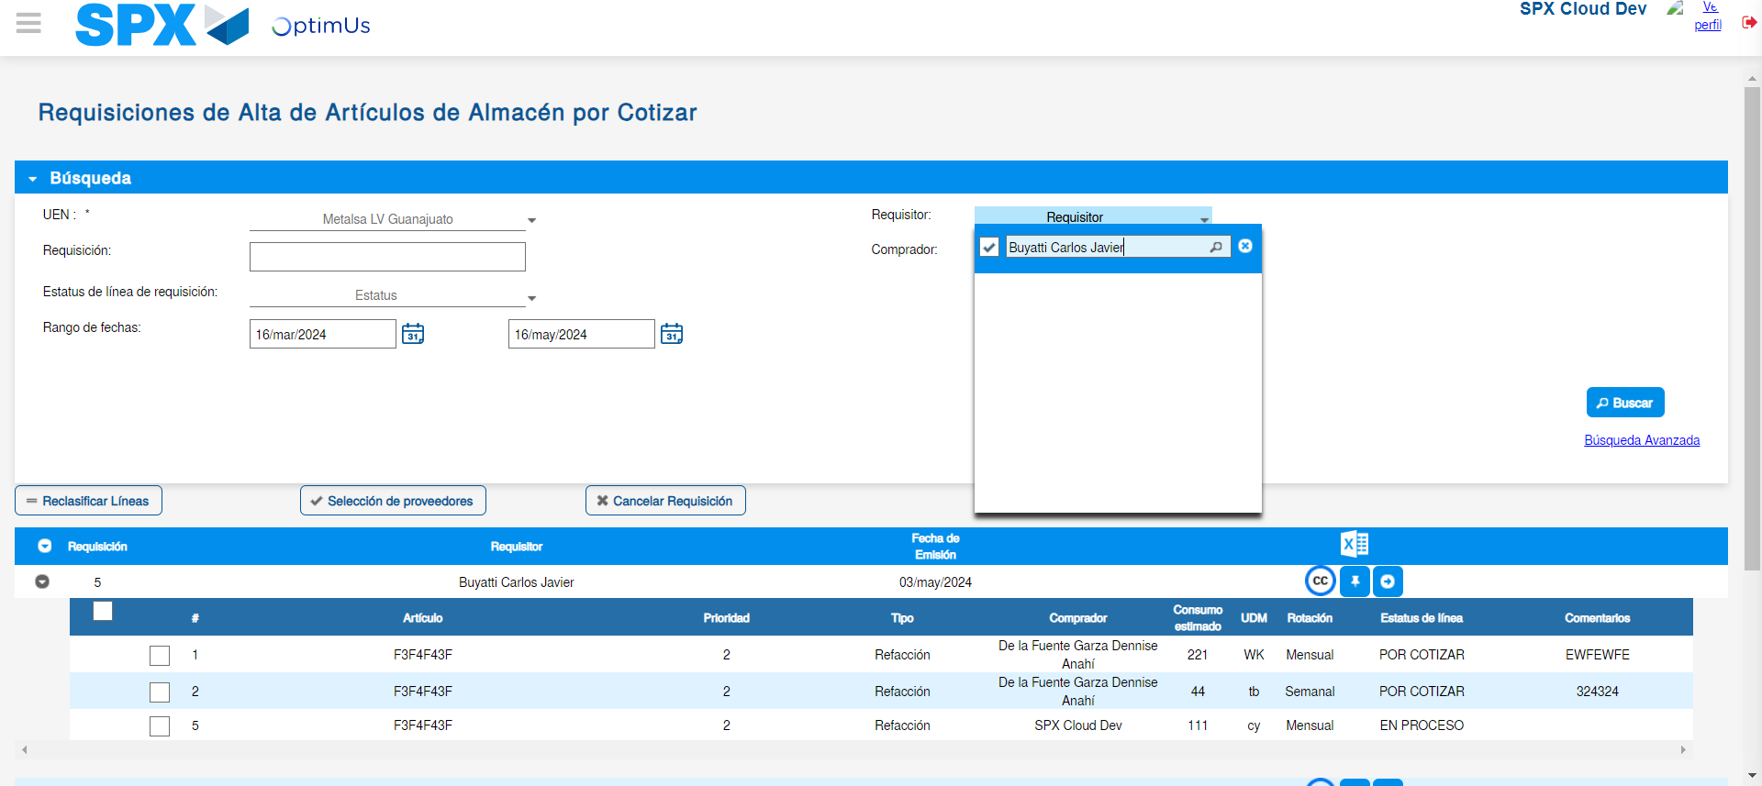Image file-name: QC_Testing-tc001_SPX_Dev5_Validar_Campos_Proceso_Nuevo_Articulos_Almacen-may. 16 2024, 04 24 29 p. m.

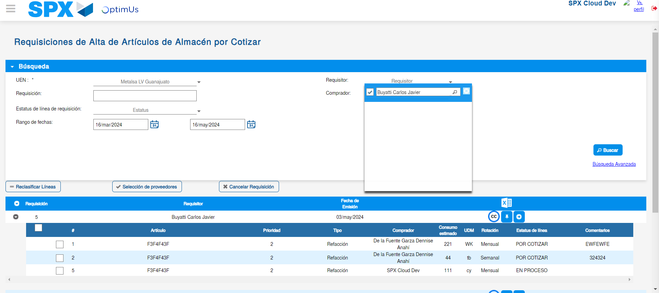Image file-name: QC_Testing-tc001_SPX_Dev5_Validar_Campos_Proceso_Nuevo_Articulos_Almacen-may. 16 2024, 04 24 45 p. m.

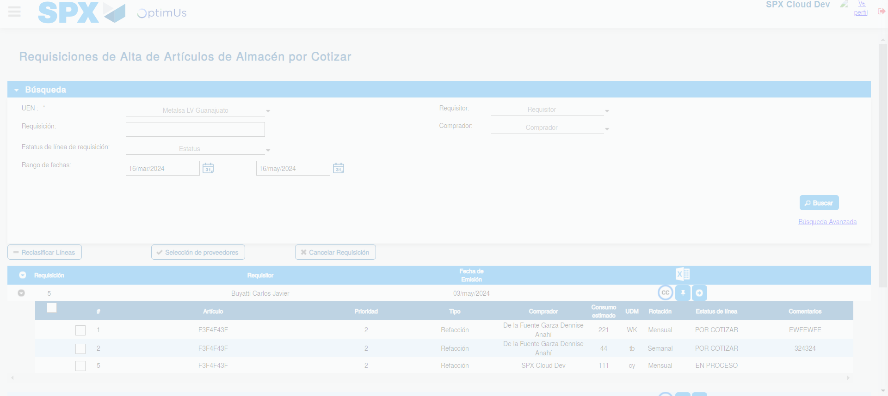Image file-name: QC_Testing-tc001_SPX_Dev5_Validar_Campos_Proceso_Nuevo_Articulos_Almacen-may. 16 2024, 04 24 49 p. m.

Image file-name: QC_Testing-tc001_SPX_Dev5_Validar_Campos_Proceso_Nuevo_Articulos_Almacen-may. 16 2024, 04 24 52 p. m.

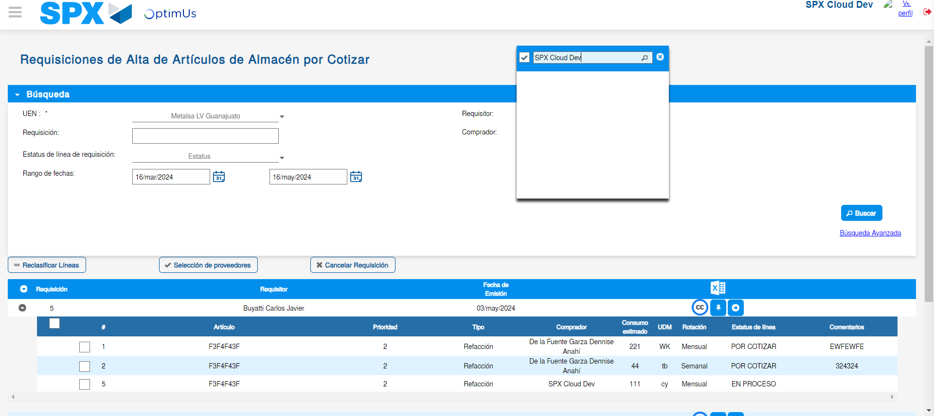Image file-name: QC_Testing-tc001_SPX_Dev5_Validar_Campos_Proceso_Nuevo_Articulos_Almacen-may. 16 2024, 04 24 53 p. m.

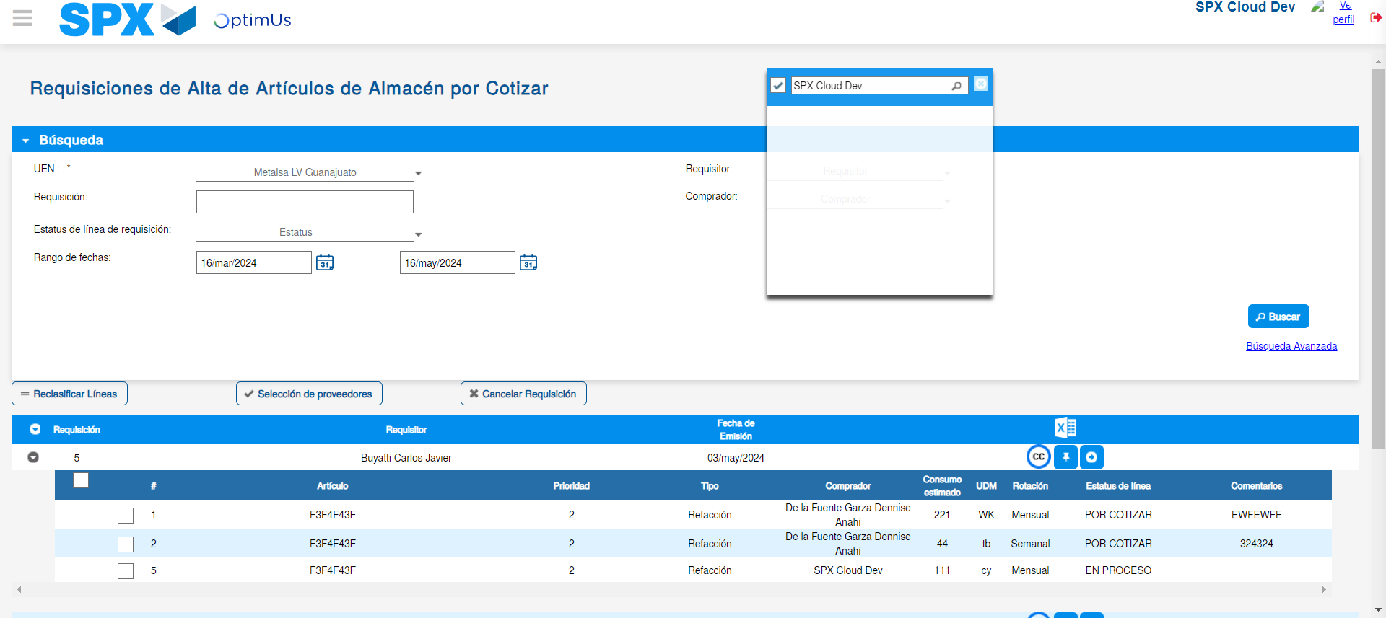Image file-name: QC_Testing-tc001_SPX_Dev5_Validar_Campos_Proceso_Nuevo_Articulos_Almacen-may. 16 2024, 04 25 10 p. m.

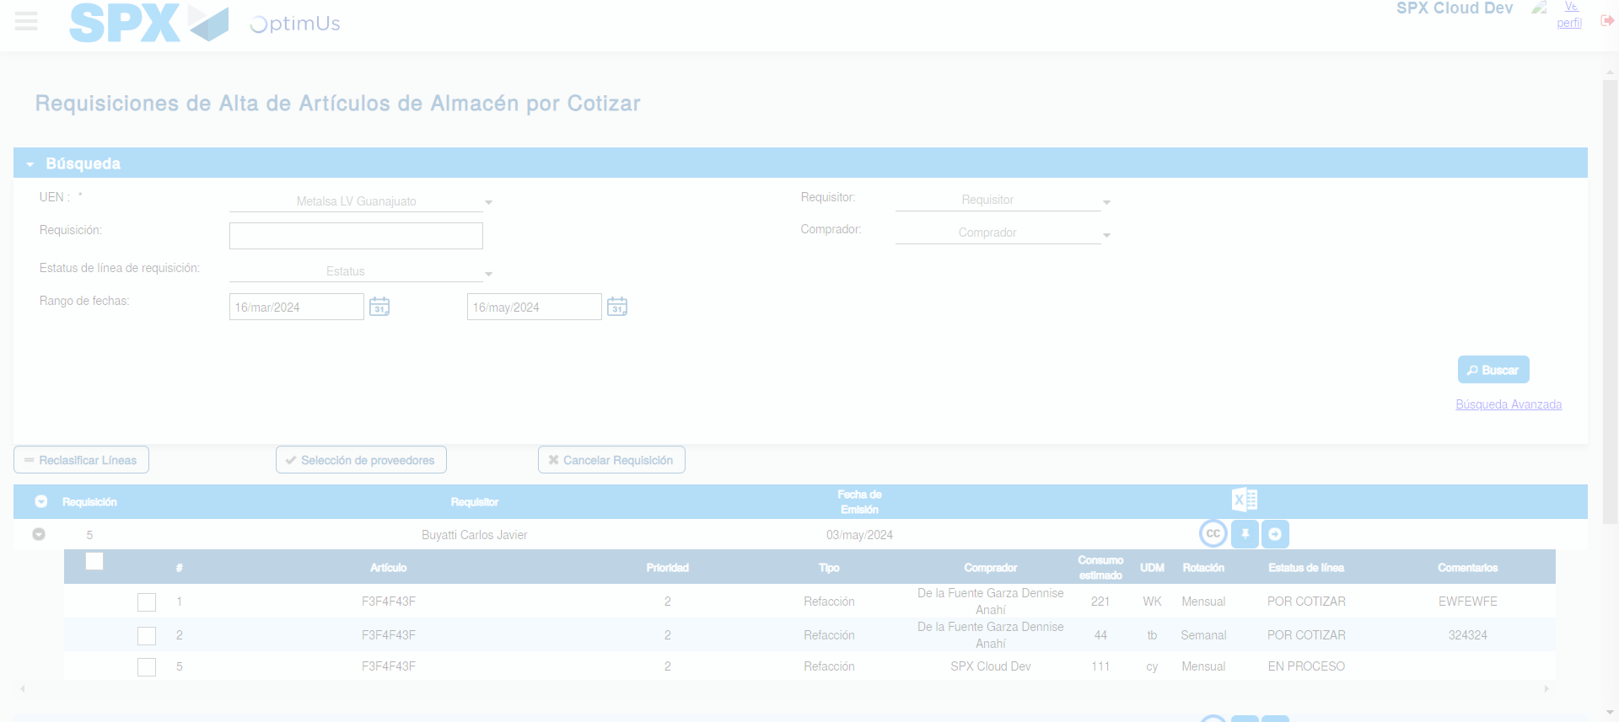Image file-name: QC_Testing-tc001_SPX_Dev5_Validar_Campos_Proceso_Nuevo_Articulos_Almacen-may. 16 2024, 04 25 13 p. m.

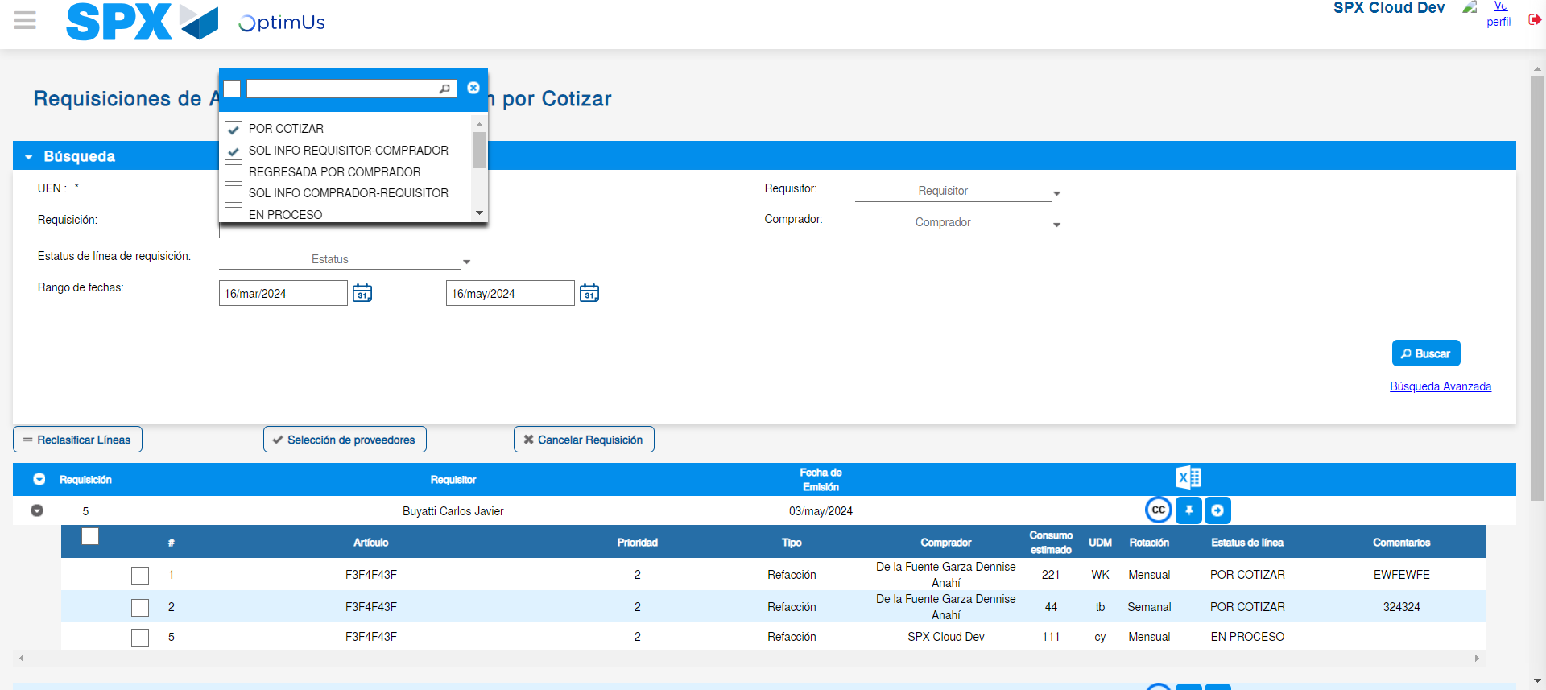Image file-name: QC_Testing-tc001_SPX_Dev5_Validar_Campos_Proceso_Nuevo_Articulos_Almacen-may. 16 2024, 04 25 17 p. m.

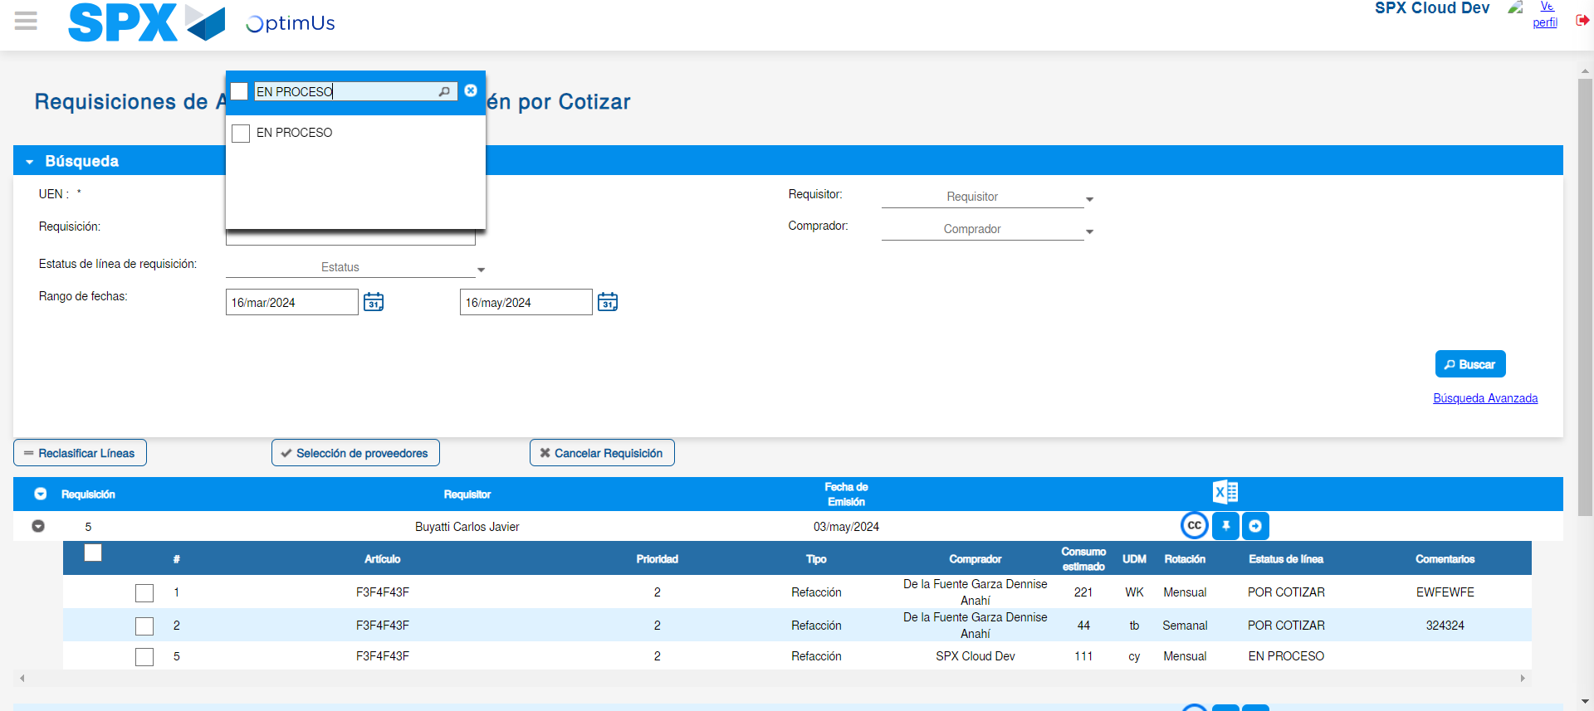Image file-name: QC_Testing-tc001_SPX_Dev5_Validar_Campos_Proceso_Nuevo_Articulos_Almacen-may. 16 2024, 04 25 18 p. m.

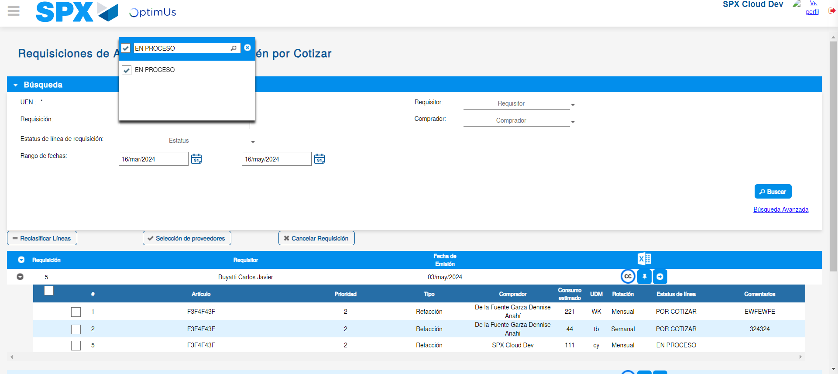Image file-name: QC_Testing-tc001_SPX_Dev5_Validar_Campos_Proceso_Nuevo_Articulos_Almacen-may. 16 2024, 04 25 21 p. m.

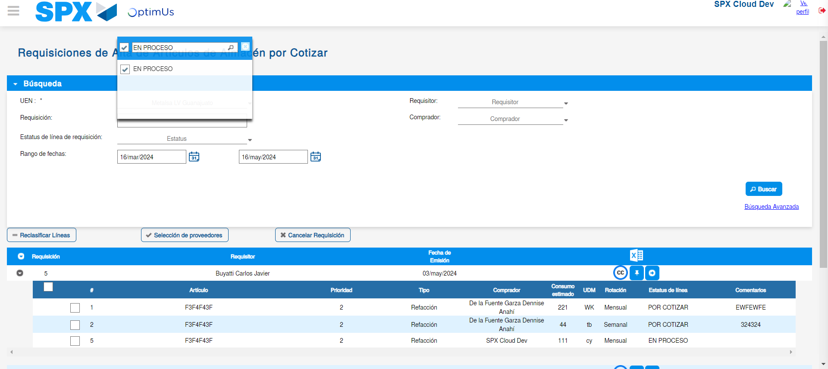Image file-name: QC_Testing-tc001_SPX_Dev5_Validar_Campos_Proceso_Nuevo_Articulos_Almacen-may. 16 2024, 04 25 25 p. m.

Image file-name: QC_Testing-tc001_SPX_Dev5_Validar_Campos_Proceso_Nuevo_Articulos_Almacen-may. 16 2024, 04 25 28 p. m.

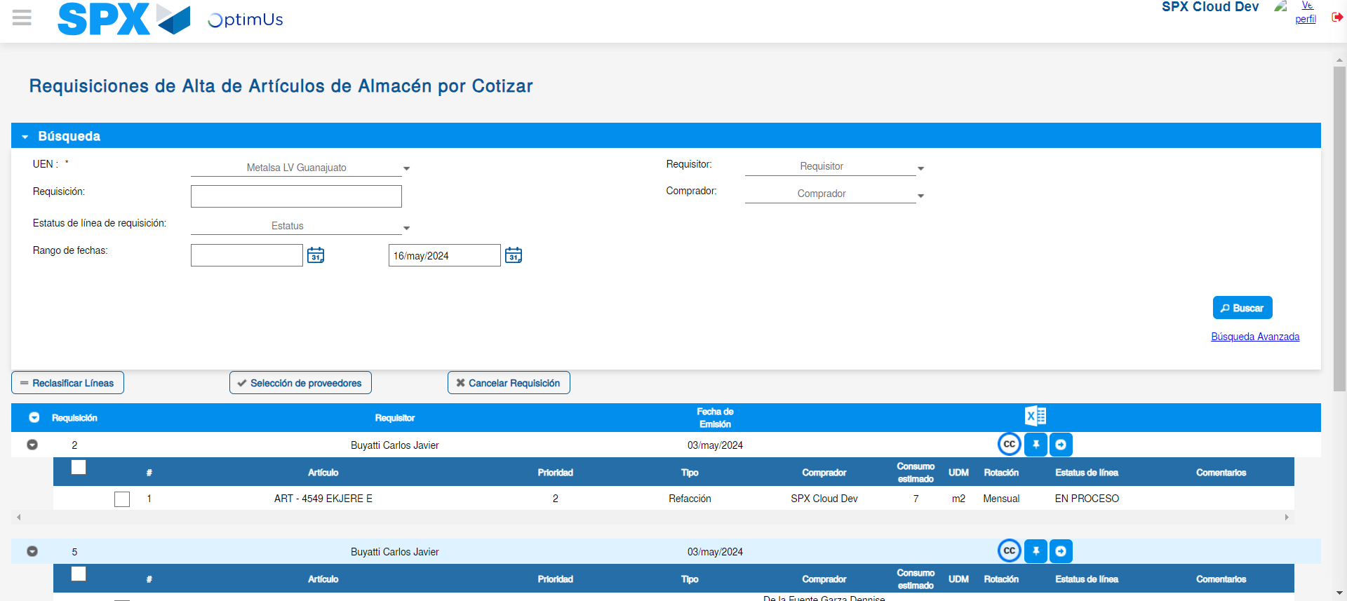Image file-name: QC_Testing-tc001_SPX_Dev5_Validar_Campos_Proceso_Nuevo_Articulos_Almacen-may. 16 2024, 04 25 32 p. m.

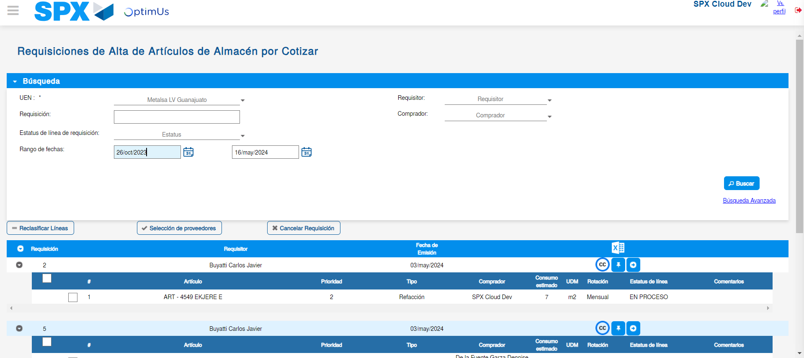Image file-name: QC_Testing-tc001_SPX_Dev5_Validar_Campos_Proceso_Nuevo_Articulos_Almacen-may. 16 2024, 04 25 33 p. m.

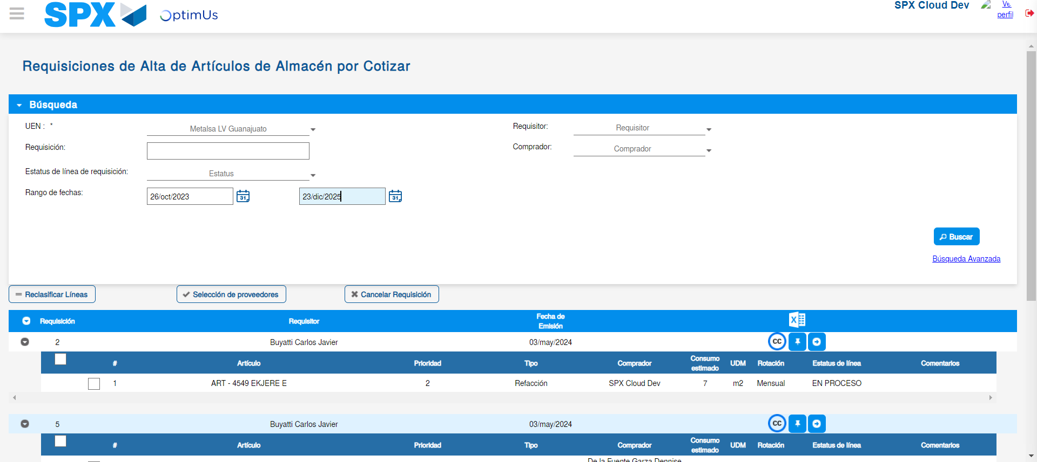Image file-name: QC_Testing-tc001_SPX_Dev5_Validar_Campos_Proceso_Nuevo_Articulos_Almacen-may. 16 2024, 04 25 36 p. m.

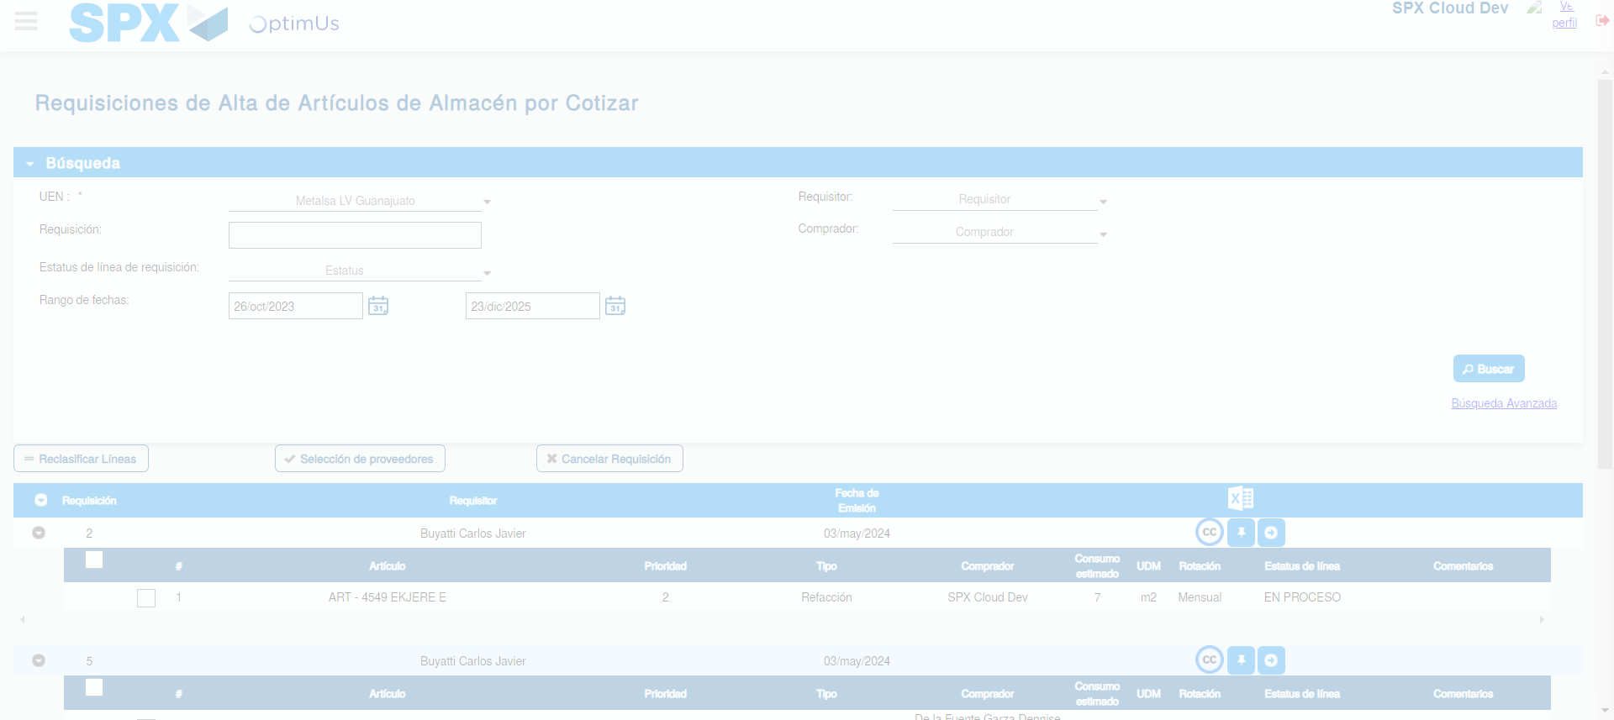Image file-name: QC_Testing-tc001_SPX_Dev5_Validar_Campos_Proceso_Nuevo_Articulos_Almacen-may. 16 2024, 04 25 40 p. m.

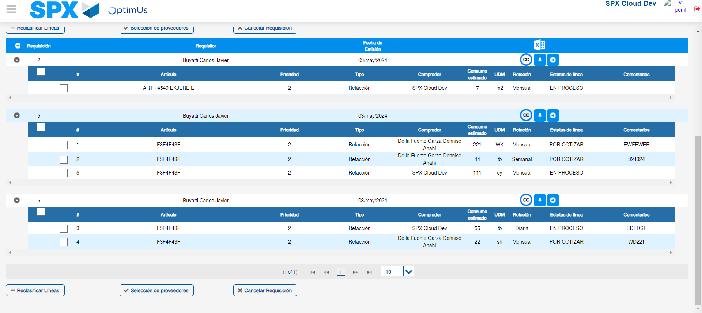Image file-name: QC_Testing-tc001_SPX_Dev5_Validar_Campos_Proceso_Nuevo_Articulos_Almacen-may. 16 2024, 04 25 43 p. m.

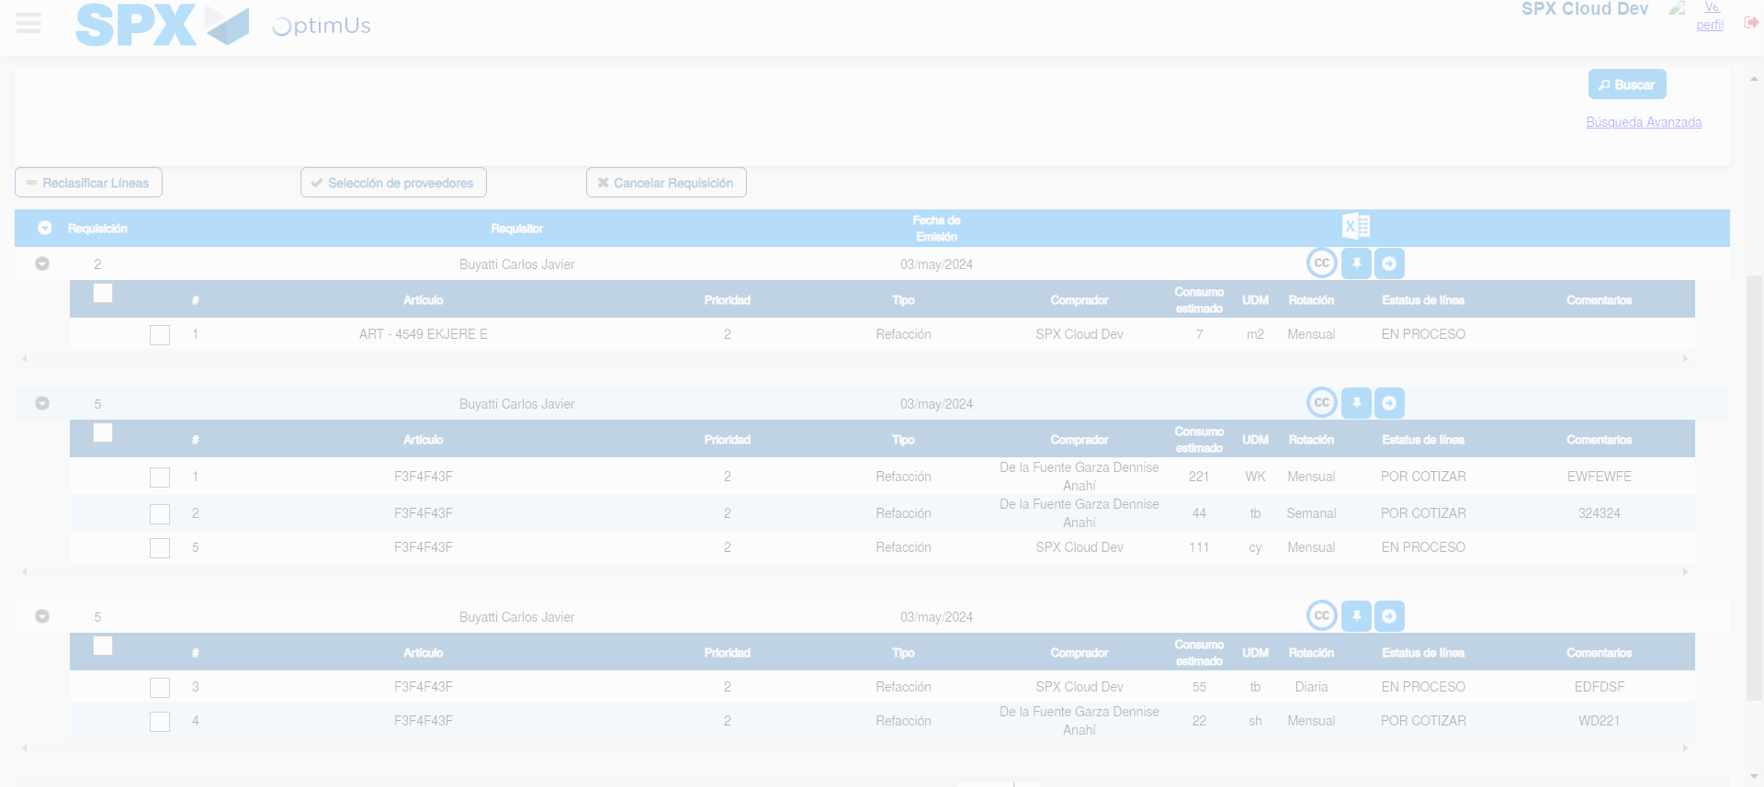Image file-name: QC_Testing-tc001_SPX_Dev5_Validar_Campos_Proceso_Nuevo_Articulos_Almacen-may. 16 2024, 04 25 44 p. m.

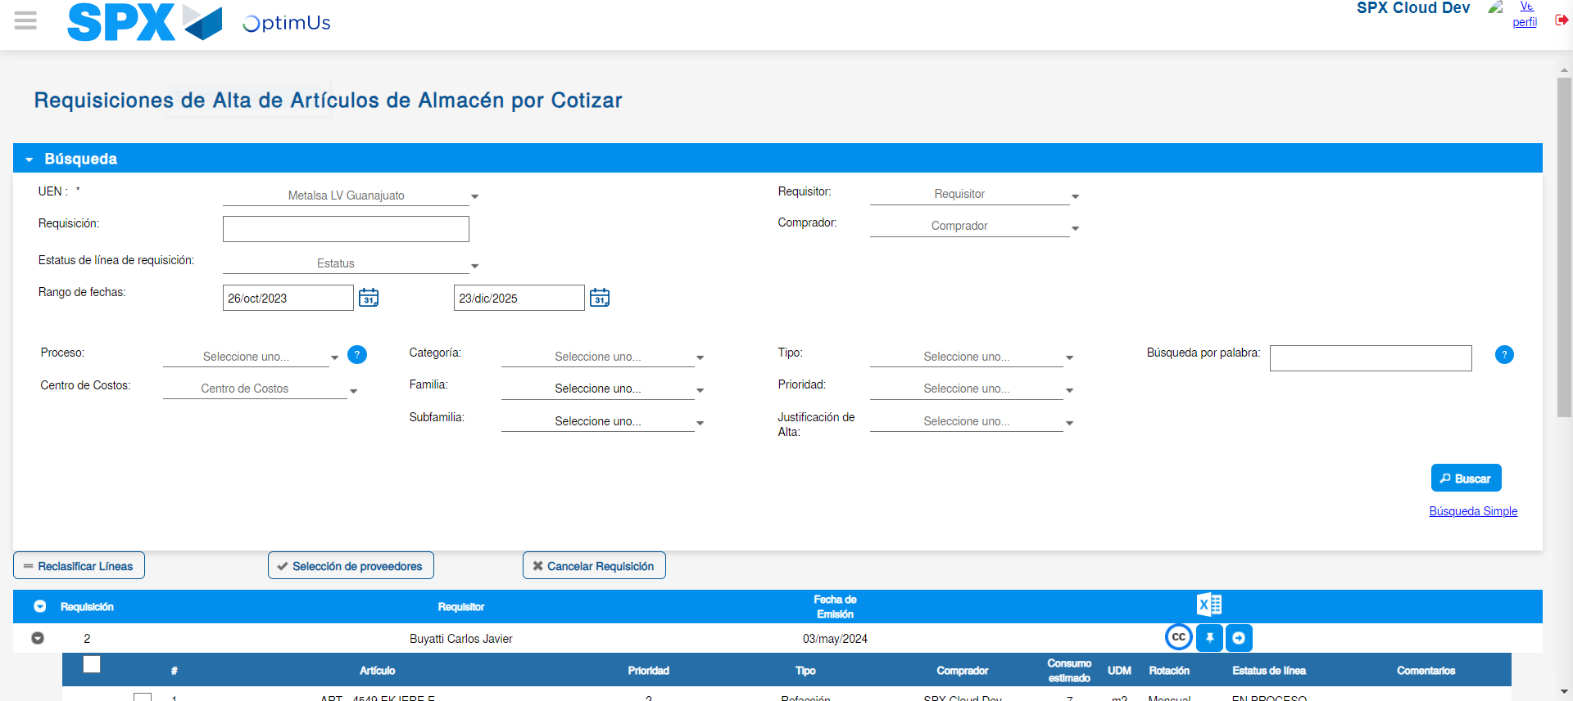Image file-name: QC_Testing-tc001_SPX_Dev5_Validar_Campos_Proceso_Nuevo_Articulos_Almacen-may. 16 2024, 04 25 45 p. m.

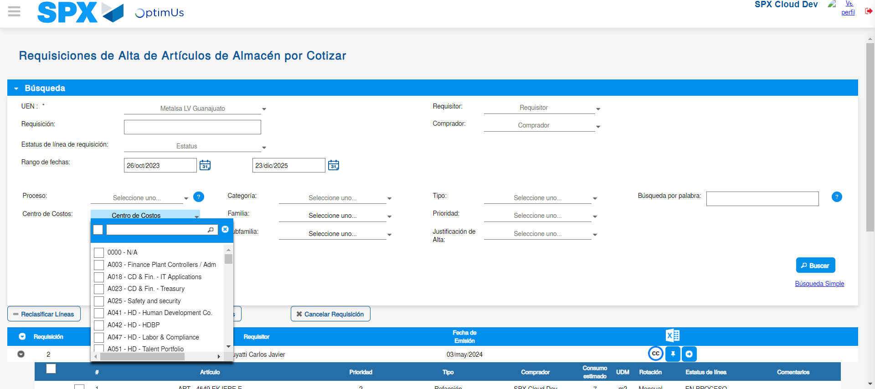Image file-name: QC_Testing-tc001_SPX_Dev5_Validar_Campos_Proceso_Nuevo_Articulos_Almacen-may. 16 2024, 04 25 56 p. m.

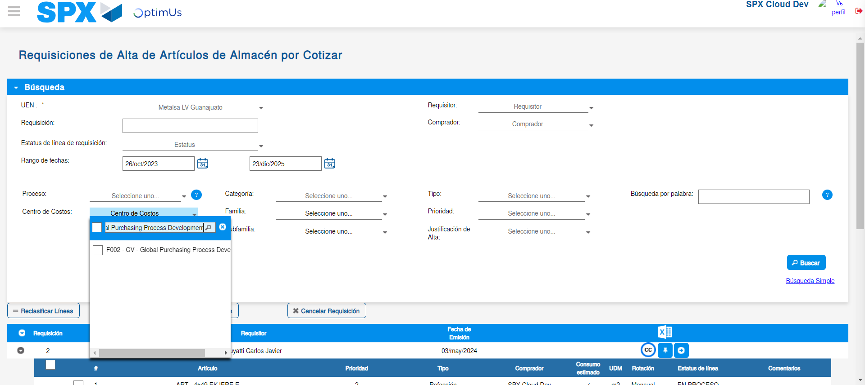Image file-name: QC_Testing-tc001_SPX_Dev5_Validar_Campos_Proceso_Nuevo_Articulos_Almacen-may. 16 2024, 04 25 58 p. m.

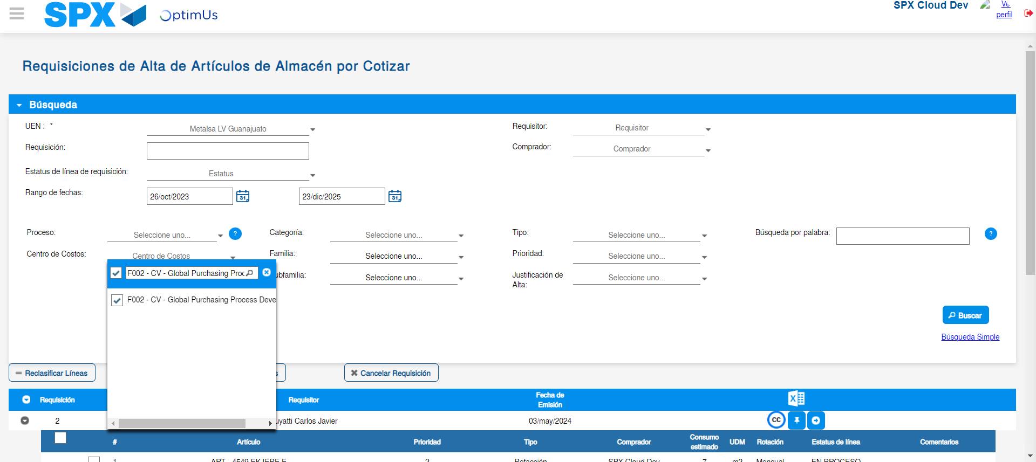Image file-name: QC_Testing-tc001_SPX_Dev5_Validar_Campos_Proceso_Nuevo_Articulos_Almacen-may. 16 2024, 04 26 01 p. m.

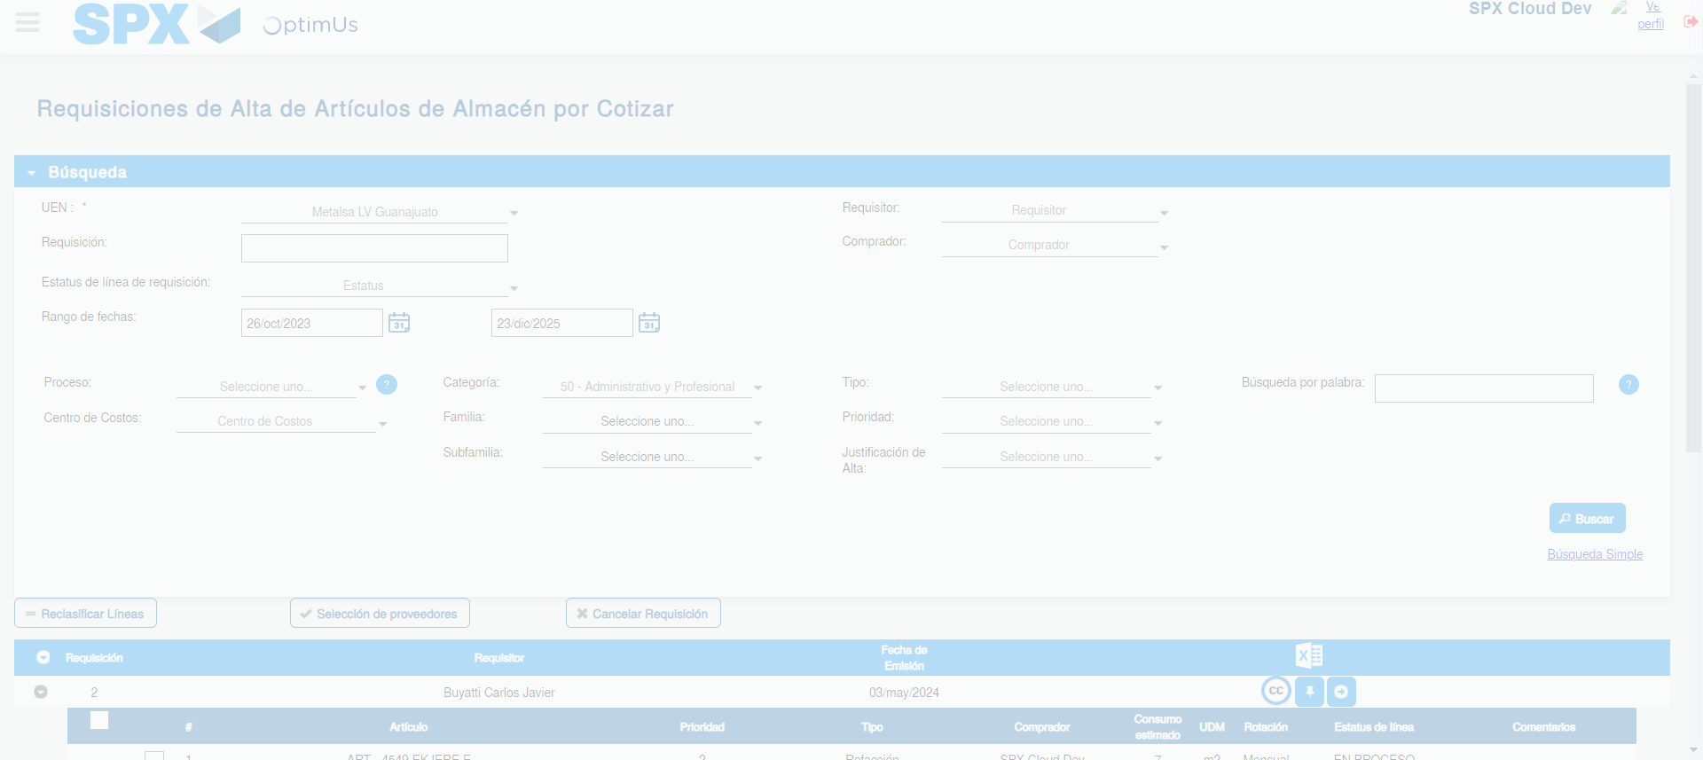Image file-name: QC_Testing-tc001_SPX_Dev5_Validar_Campos_Proceso_Nuevo_Articulos_Almacen-may. 16 2024, 04 26 05 p. m.

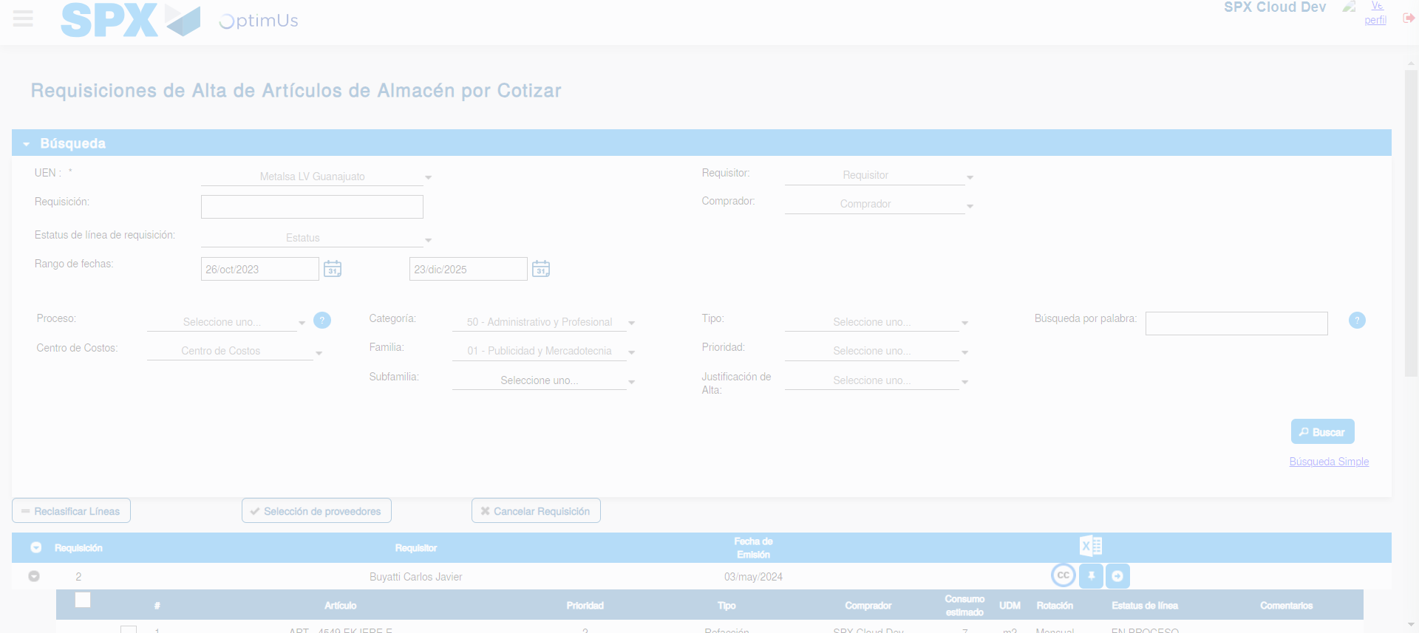Image file-name: QC_Testing-tc001_SPX_Dev5_Validar_Campos_Proceso_Nuevo_Articulos_Almacen-may. 16 2024, 04 26 09 p. m.

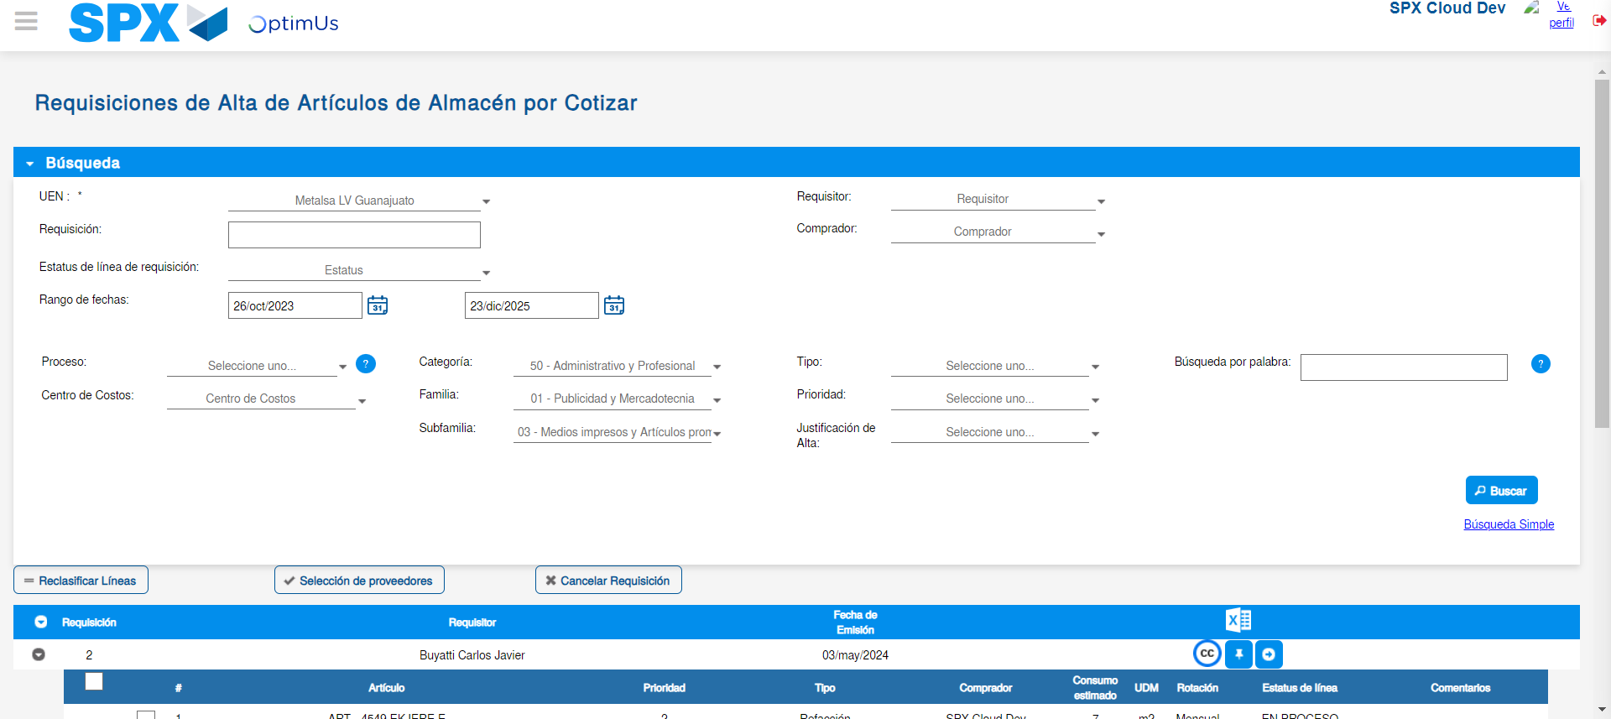Image file-name: QC_Testing-tc001_SPX_Dev5_Validar_Campos_Proceso_Nuevo_Articulos_Almacen-may. 16 2024, 04 26 13 p. m.

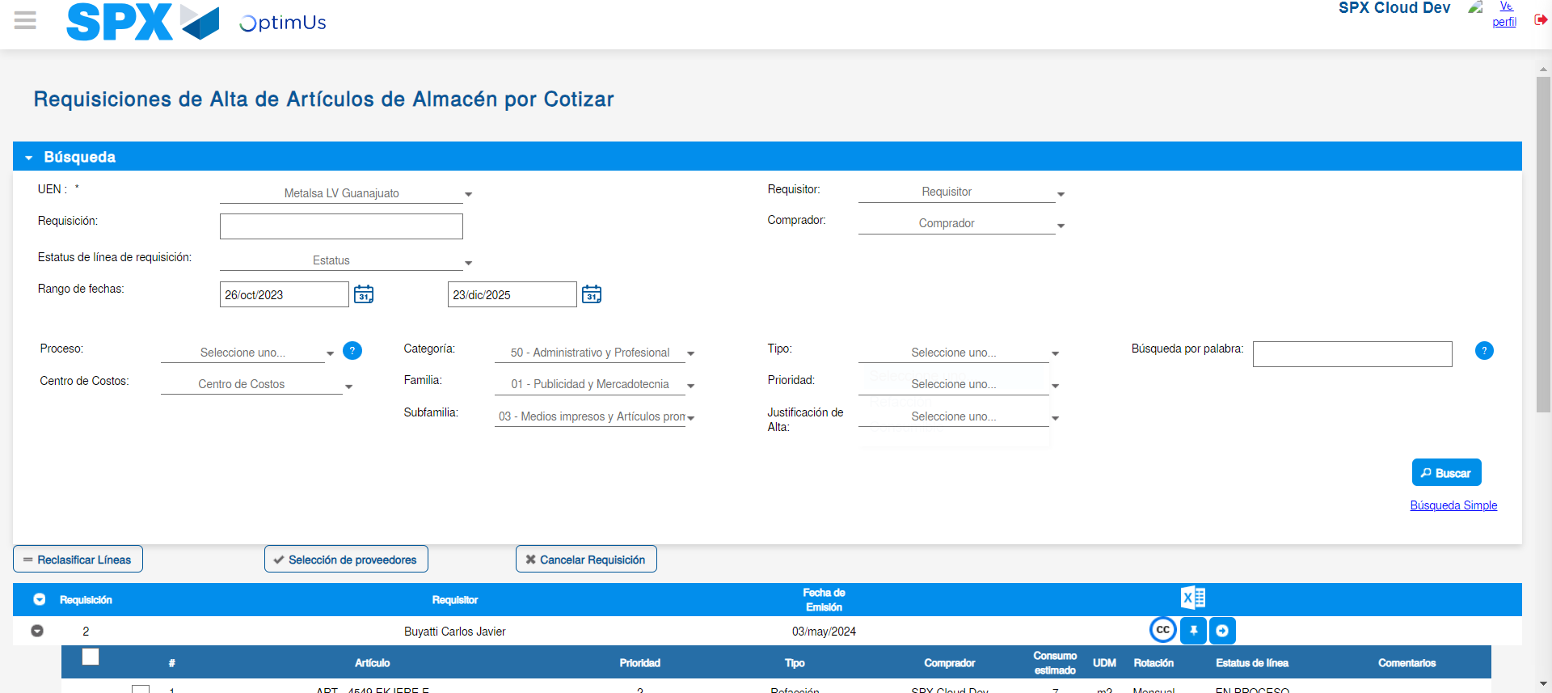Image file-name: QC_Testing-tc001_SPX_Dev5_Validar_Campos_Proceso_Nuevo_Articulos_Almacen-may. 16 2024, 04 26 16 p. m.

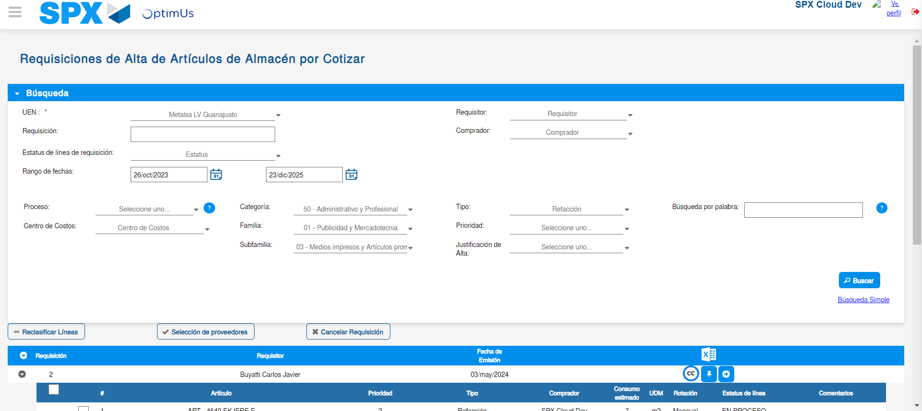Image file-name: QC_Testing-tc001_SPX_Dev5_Validar_Campos_Proceso_Nuevo_Articulos_Almacen-may. 16 2024, 04 26 17 p. m.

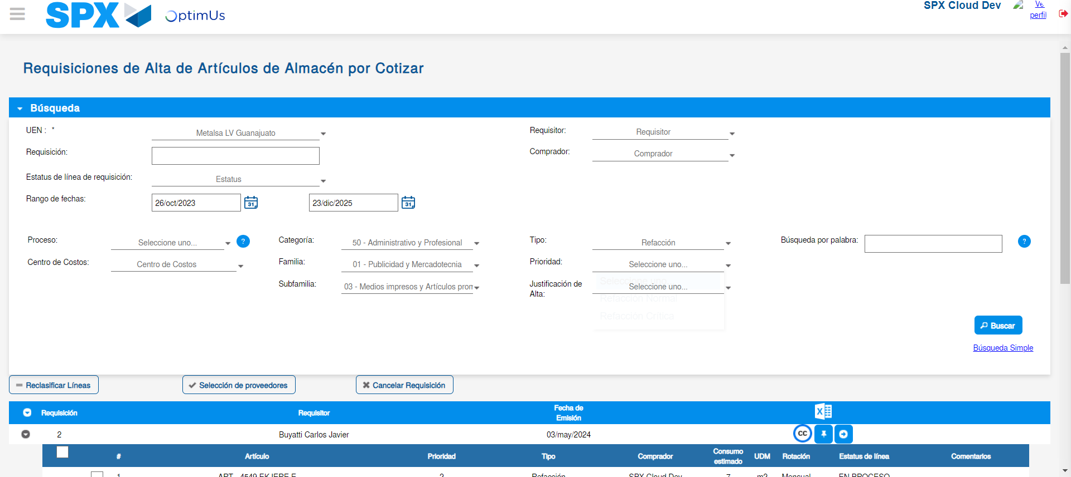Image file-name: QC_Testing-tc001_SPX_Dev5_Validar_Campos_Proceso_Nuevo_Articulos_Almacen-may. 16 2024, 04 26 20 p. m.

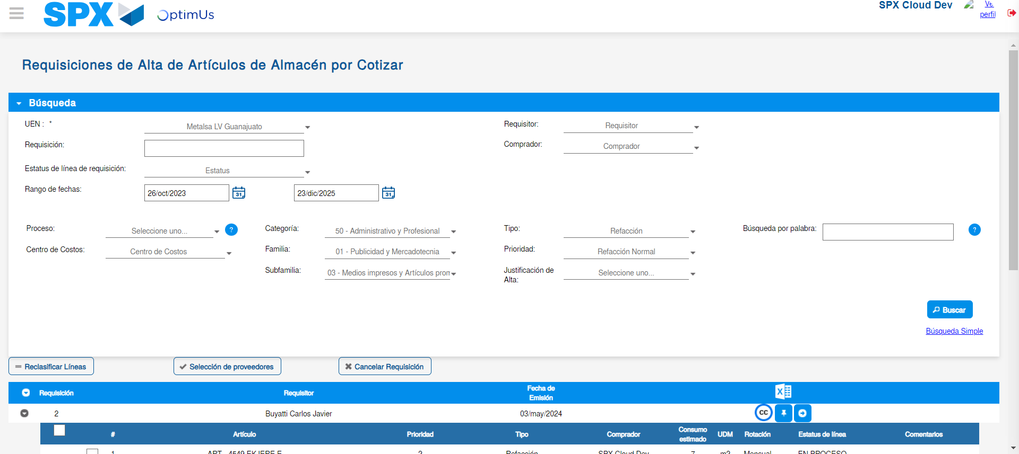Image file-name: QC_Testing-tc001_SPX_Dev5_Validar_Campos_Proceso_Nuevo_Articulos_Almacen-may. 16 2024, 04 26 21 p. m.

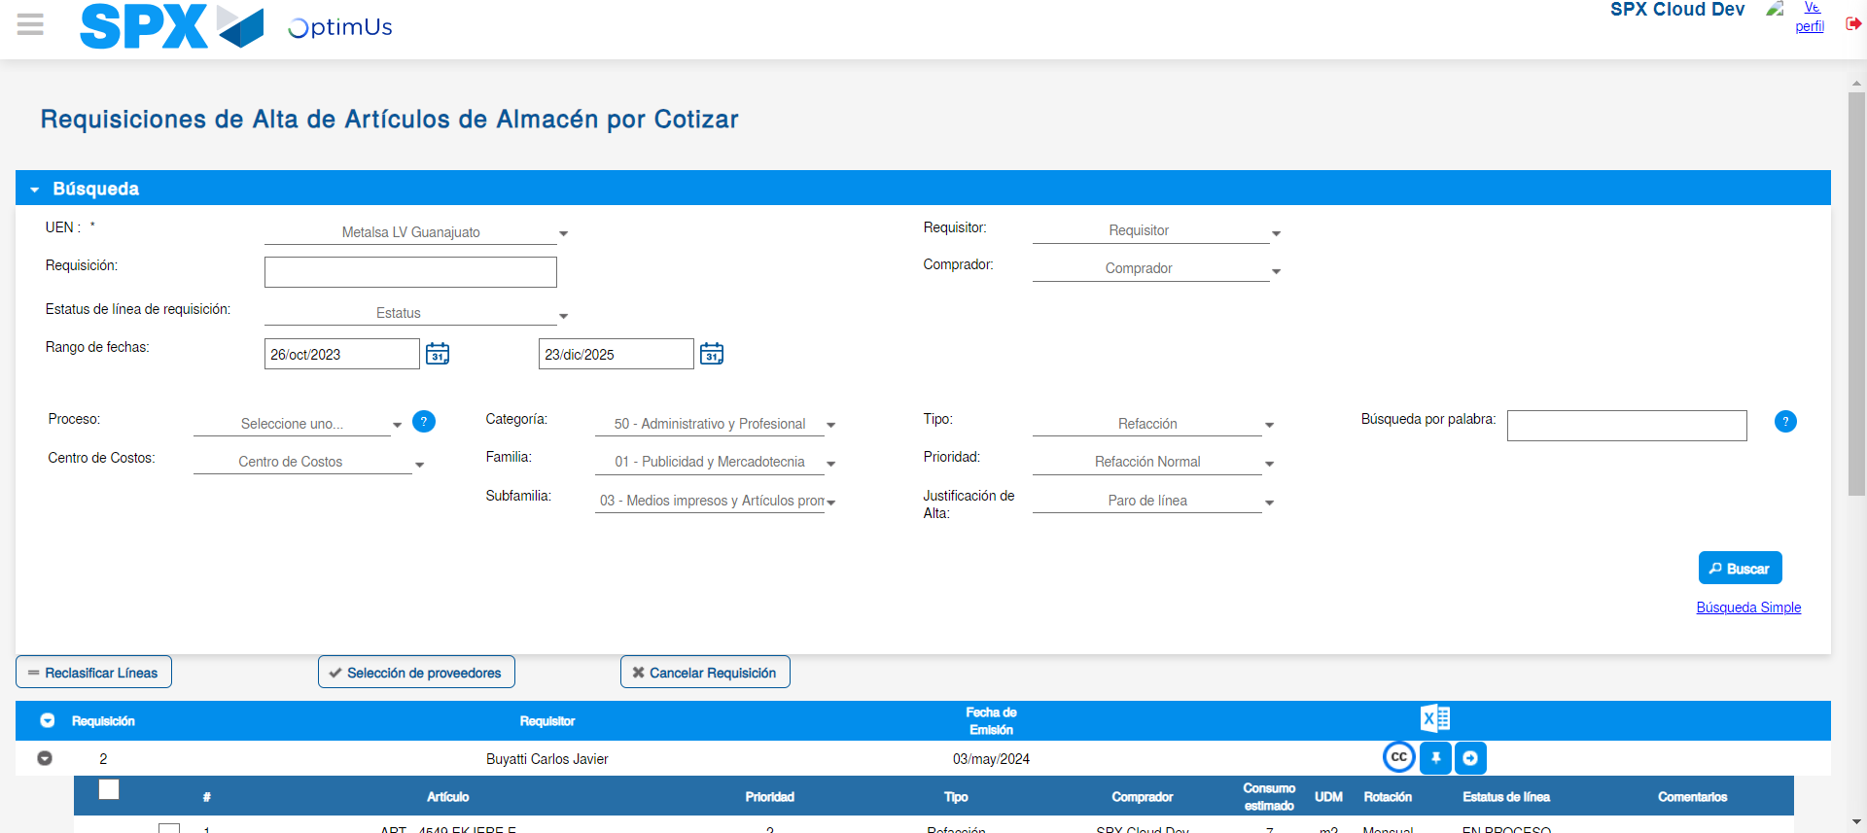Image file-name: QC_Testing-tc001_SPX_Dev5_Validar_Campos_Proceso_Nuevo_Articulos_Almacen-may. 16 2024, 04 26 24 p. m.

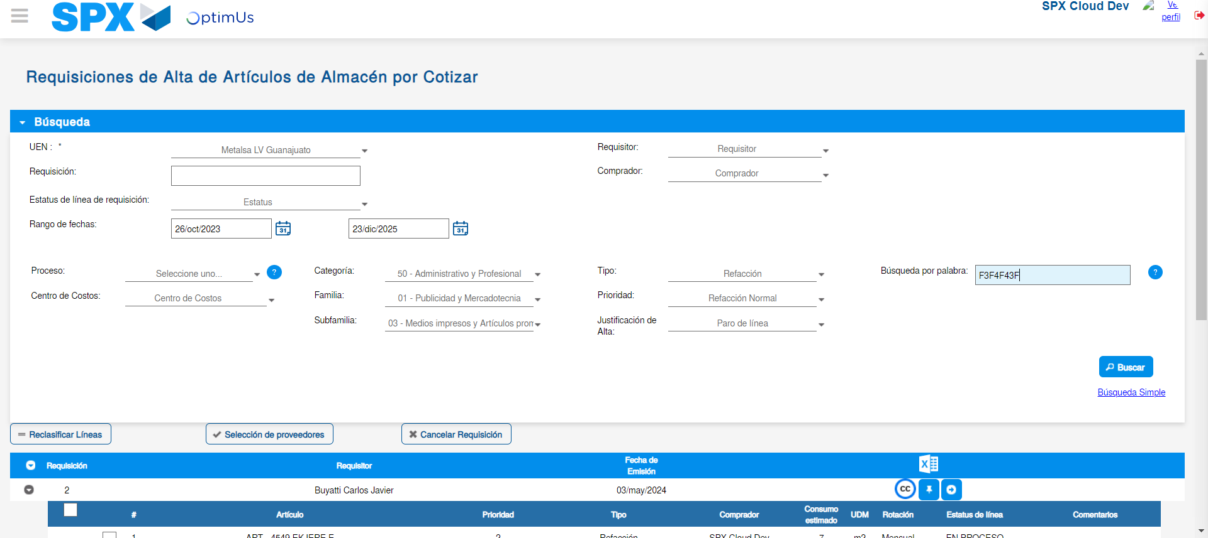Image file-name: QC_Testing-tc001_SPX_Dev5_Validar_Campos_Proceso_Nuevo_Articulos_Almacen-may. 16 2024, 04 26 28 p. m.

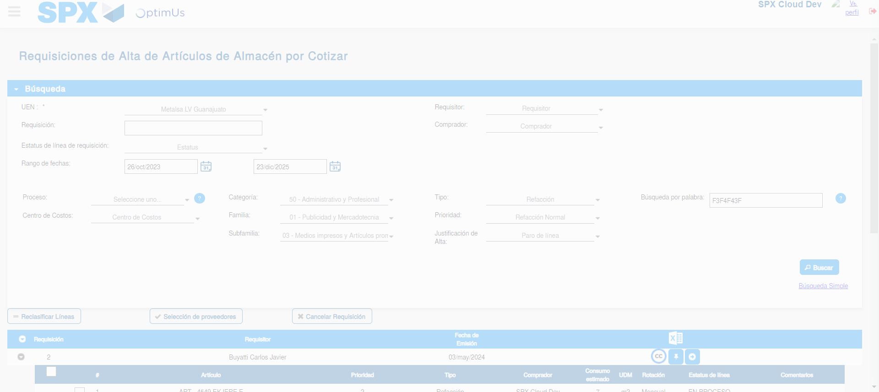Image file-name: QC_Testing-tc001_SPX_Dev5_Validar_Campos_Proceso_Nuevo_Articulos_Almacen-may. 16 2024, 04 26 31 p. m.

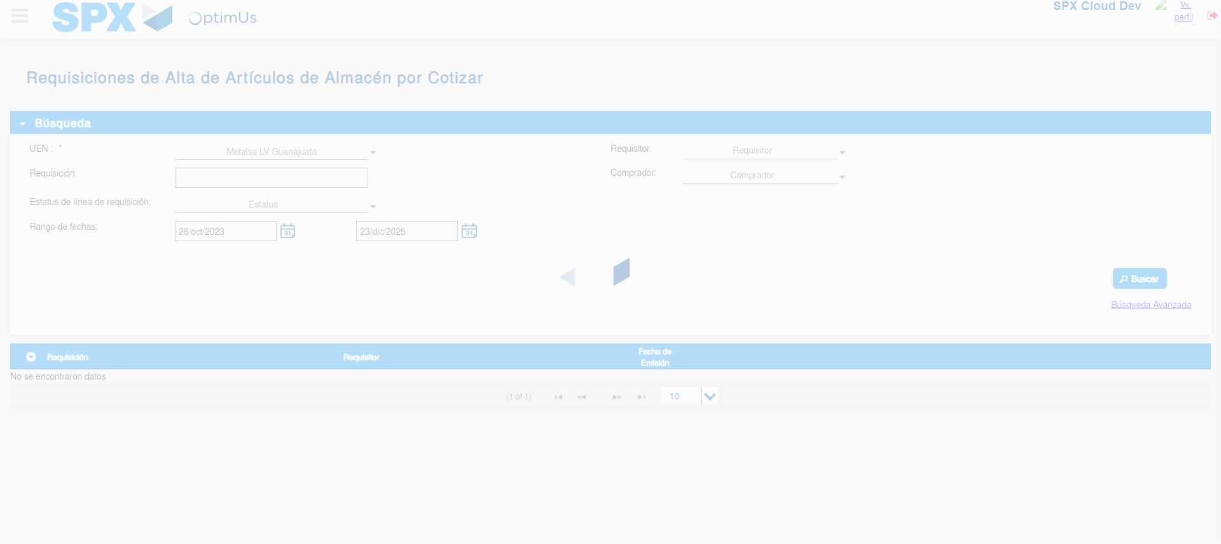Image file-name: QC_Testing-tc001_SPX_Dev5_Validar_Campos_Proceso_Nuevo_Articulos_Almacen-may. 16 2024, 04 26 35 p. m.

